**TuneTudo - User Guide**

Name: Neel Patel

Email: [neelp27@umd.edu](mailto:neelp27@umd.edu)

Pre-requisite:  
Follow the build & setup guide and start the application.

### **How to use each feature and exercise use cases**

#### [**FR-001: Search for an Artist, Album, or Song**](https://docs.google.com/document/d/13fjih7UaoteZe9ls5Qn8RElRJIKu8S-Ocv_cmukeYYM/edit?tab=t.0#heading=h.3e9ilt9piagw)

Open <http://localhost:2701>  
  
Write any song title, artist name or album in the Search bar and click on Search button or press Enter button

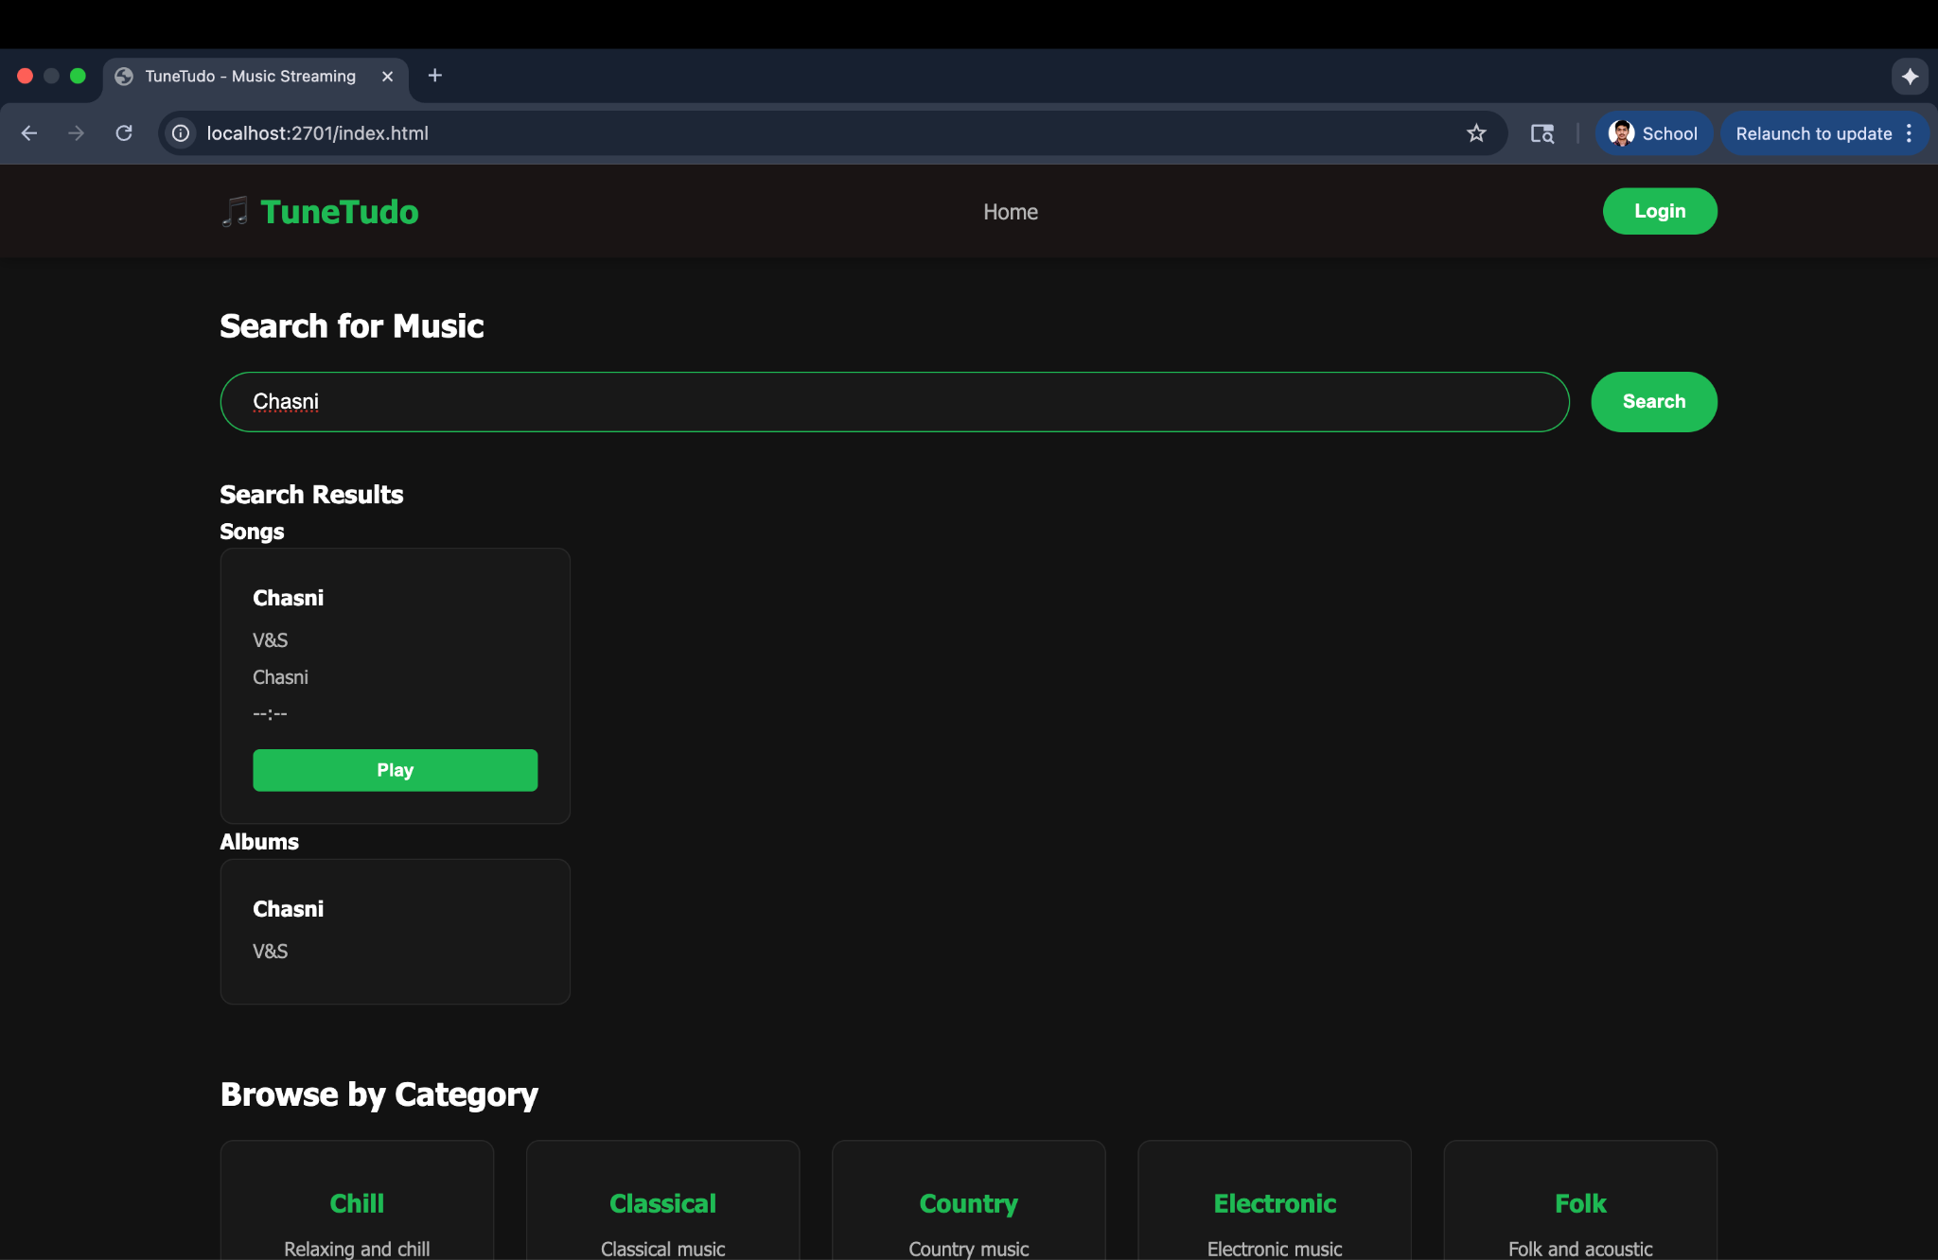

Results will be displayed.  
  
If the song is present in the catalog, it will be displayed otherwise “No results found” will be shown.  
  
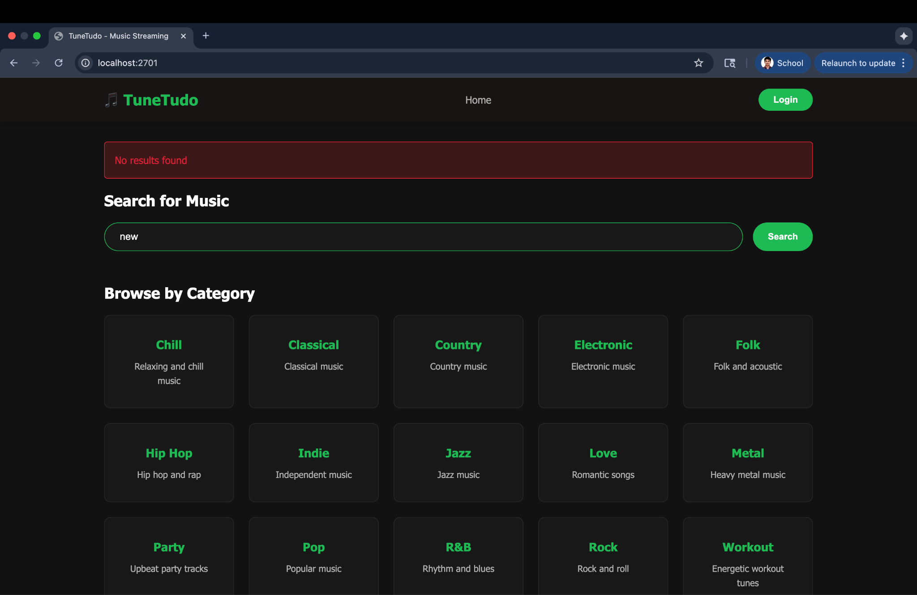

#### 

#### [**FR-002: Create a New Playlist**](https://docs.google.com/document/d/13fjih7UaoteZe9ls5Qn8RElRJIKu8S-Ocv_cmukeYYM/edit?tab=t.0#heading=h.s3bwngt5u7h0)

Pre-requisite: User must be logged in.

Open <http://localhost:2701>  
Click on Login button

Enter credentials and login successfully  
Go to Playlists page

Click “+ Create Playlist” button  
Enter playlist name and description(optional) and Click “Create Playlist” button.  
Playlist will be created successfully   
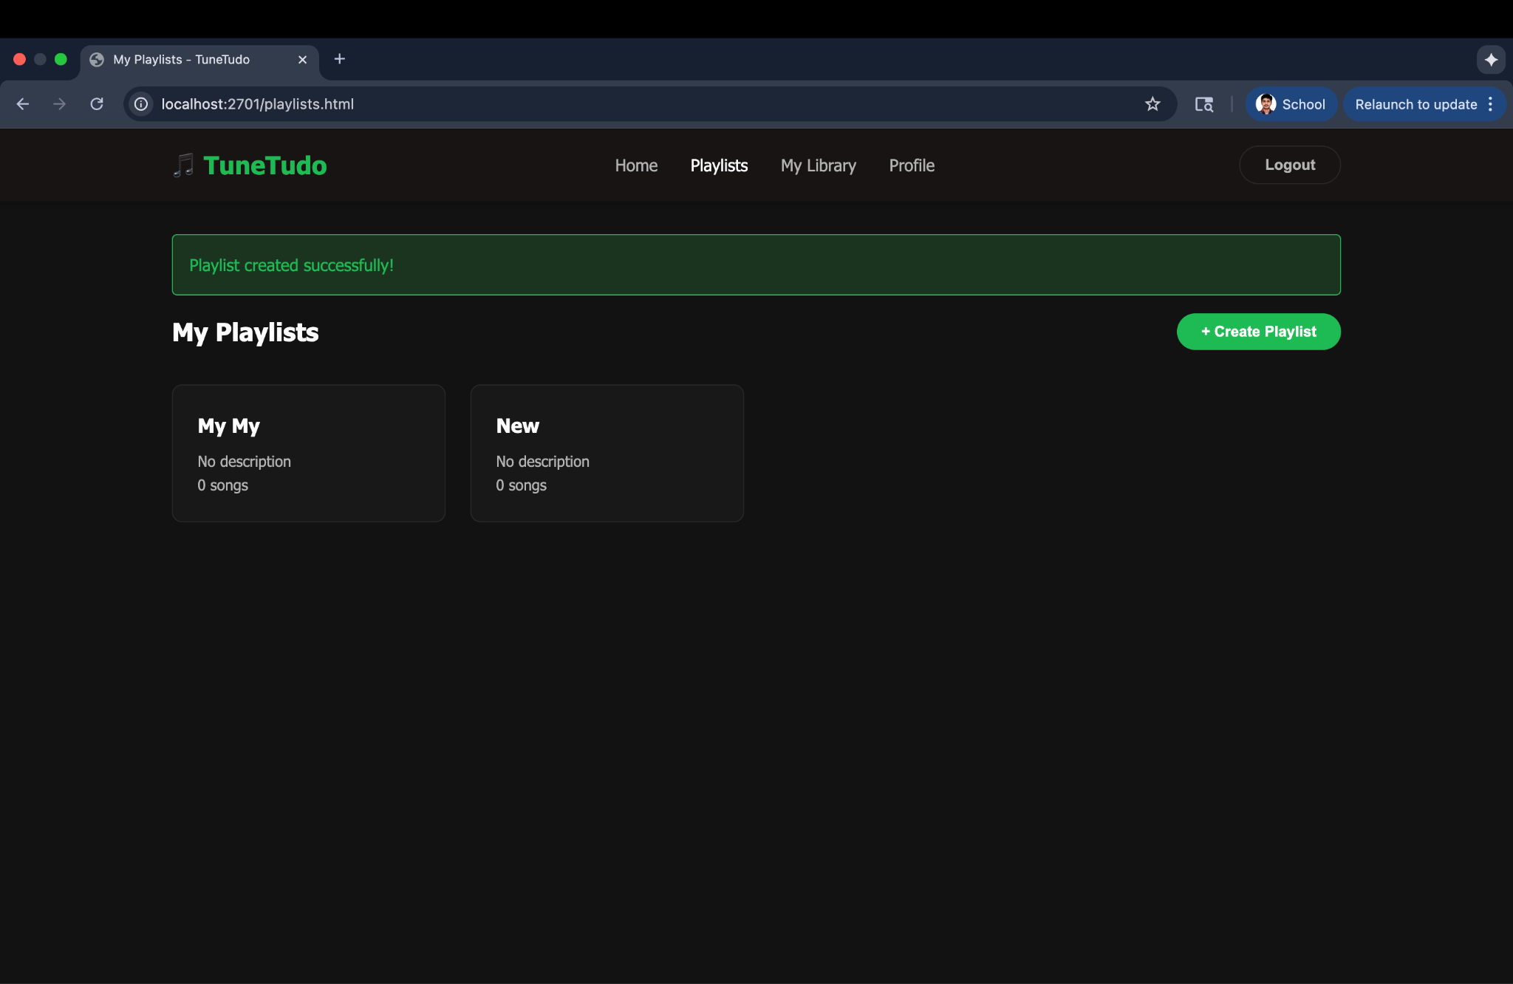  
  
If playlist exists already with the same name, error message will be shown “Playlist already exists”  
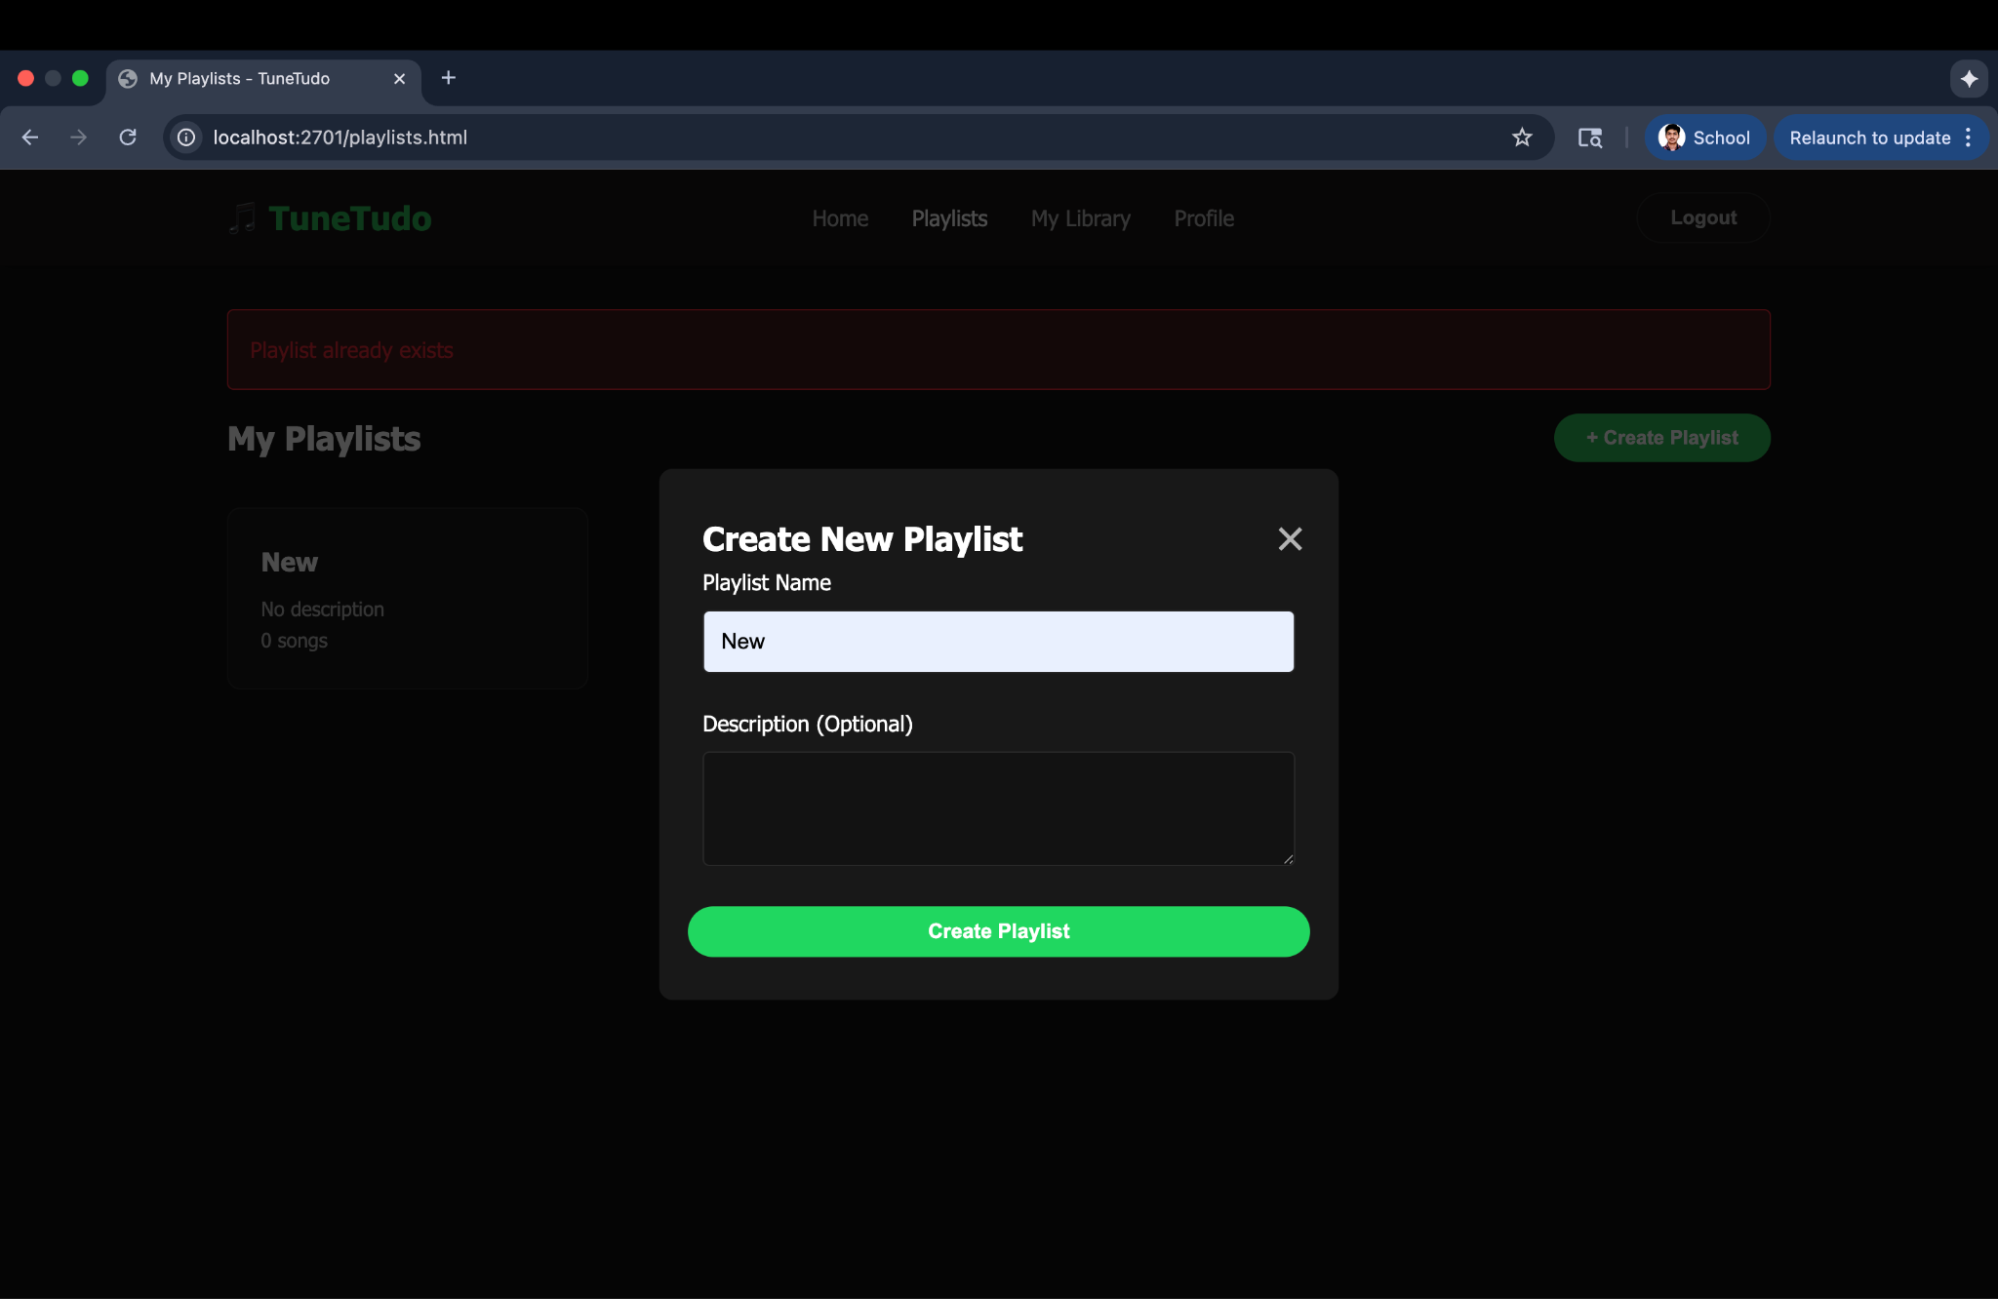

#### [**FR-003: Add a Song to an Existing Playlist**](https://docs.google.com/document/d/13fjih7UaoteZe9ls5Qn8RElRJIKu8S-Ocv_cmukeYYM/edit?tab=t.0#heading=h.psybibbho9g)

#### 

Search for a song as described in FR-001 or browse the song by category in the home page.

Click on the Add to playlist button displayed on the song card.

Select the playlist in which you want to add the song to it.

Song will be added to the playlist.

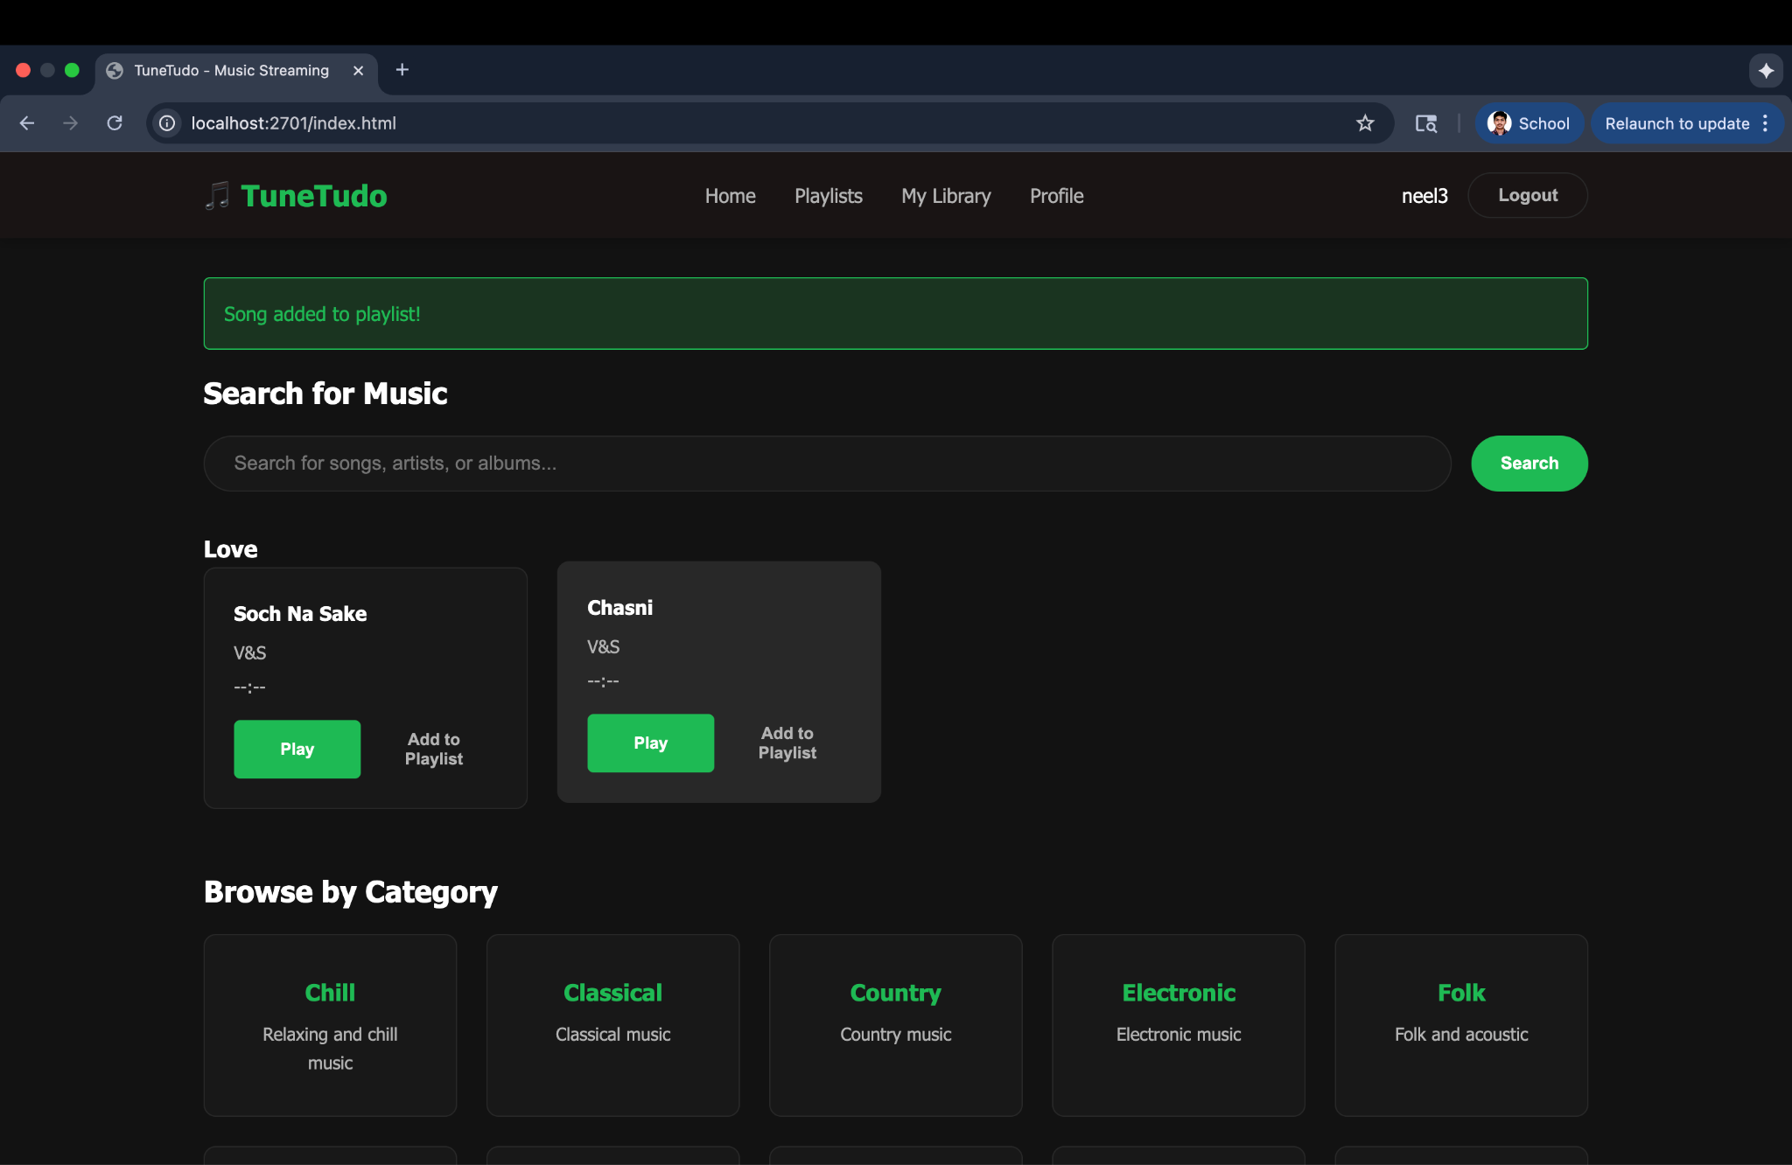

If the song is already added to the playlist and you are trying to add it again, an error message will appear.

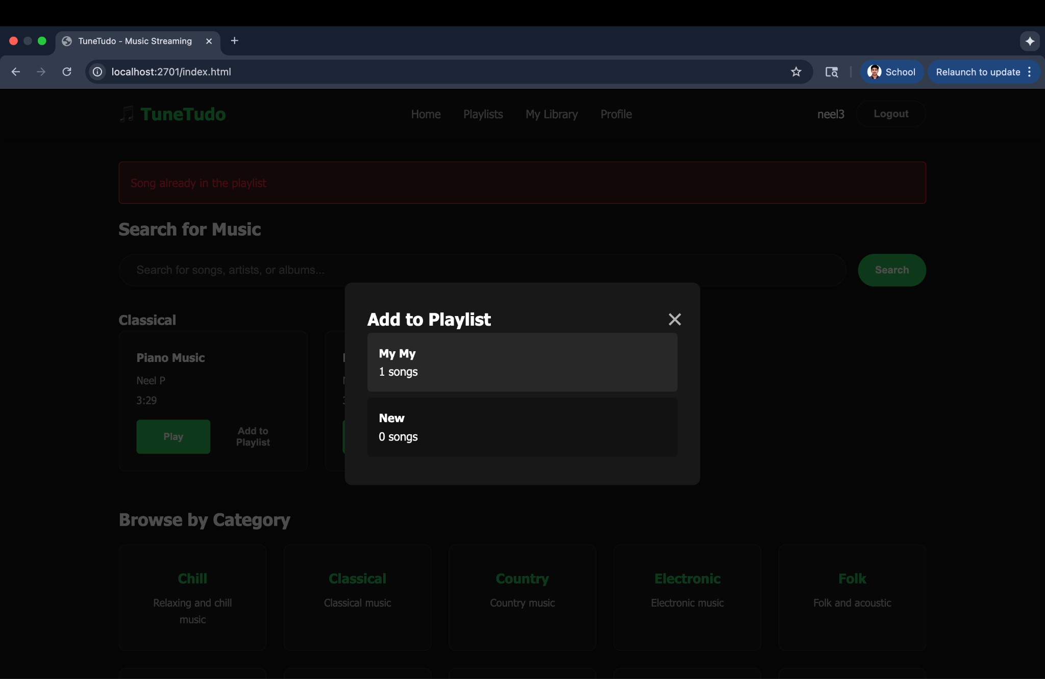

#### 

#### [**FR-004: Play a Song**](https://docs.google.com/document/d/13fjih7UaoteZe9ls5Qn8RElRJIKu8S-Ocv_cmukeYYM/edit?tab=t.0#heading=h.xuzkj6w98jys)

Search for a song as described in FR-001 or browse the song by category in the home page.

Click on “Play” button on the song card

Song will be played.  
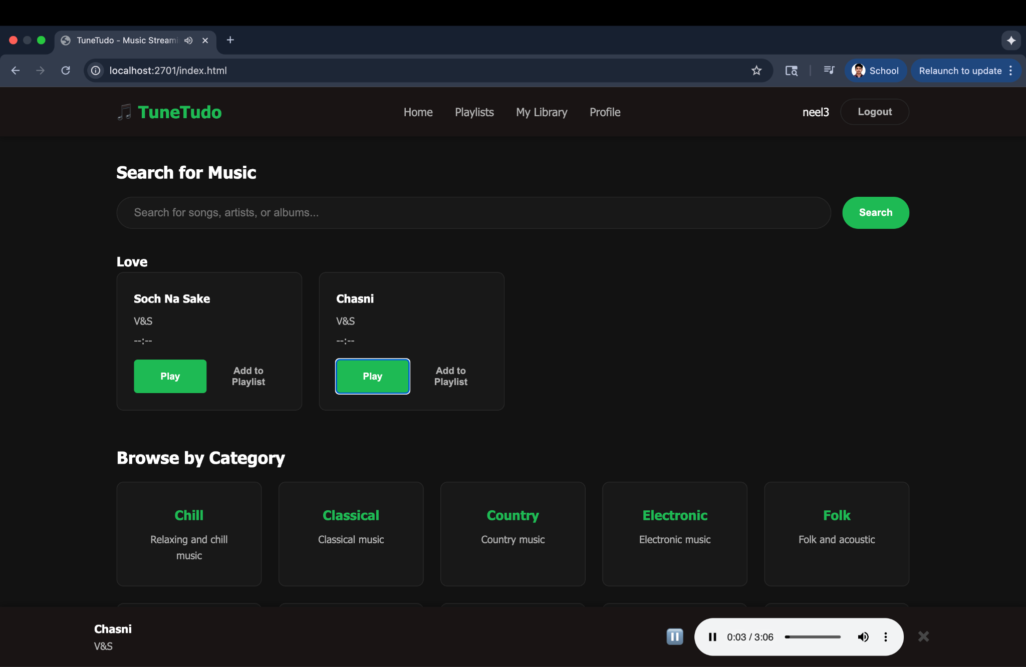

#### 

#### [**FR-005: Browse Tracks by Category**](https://docs.google.com/document/d/13fjih7UaoteZe9ls5Qn8RElRJIKu8S-Ocv_cmukeYYM/edit?tab=t.0#heading=h.5i9dy3c8hp0s)

Browse by category will appear automatically on the home page.

Just click on any category and all the songs in that category will be displayed.  
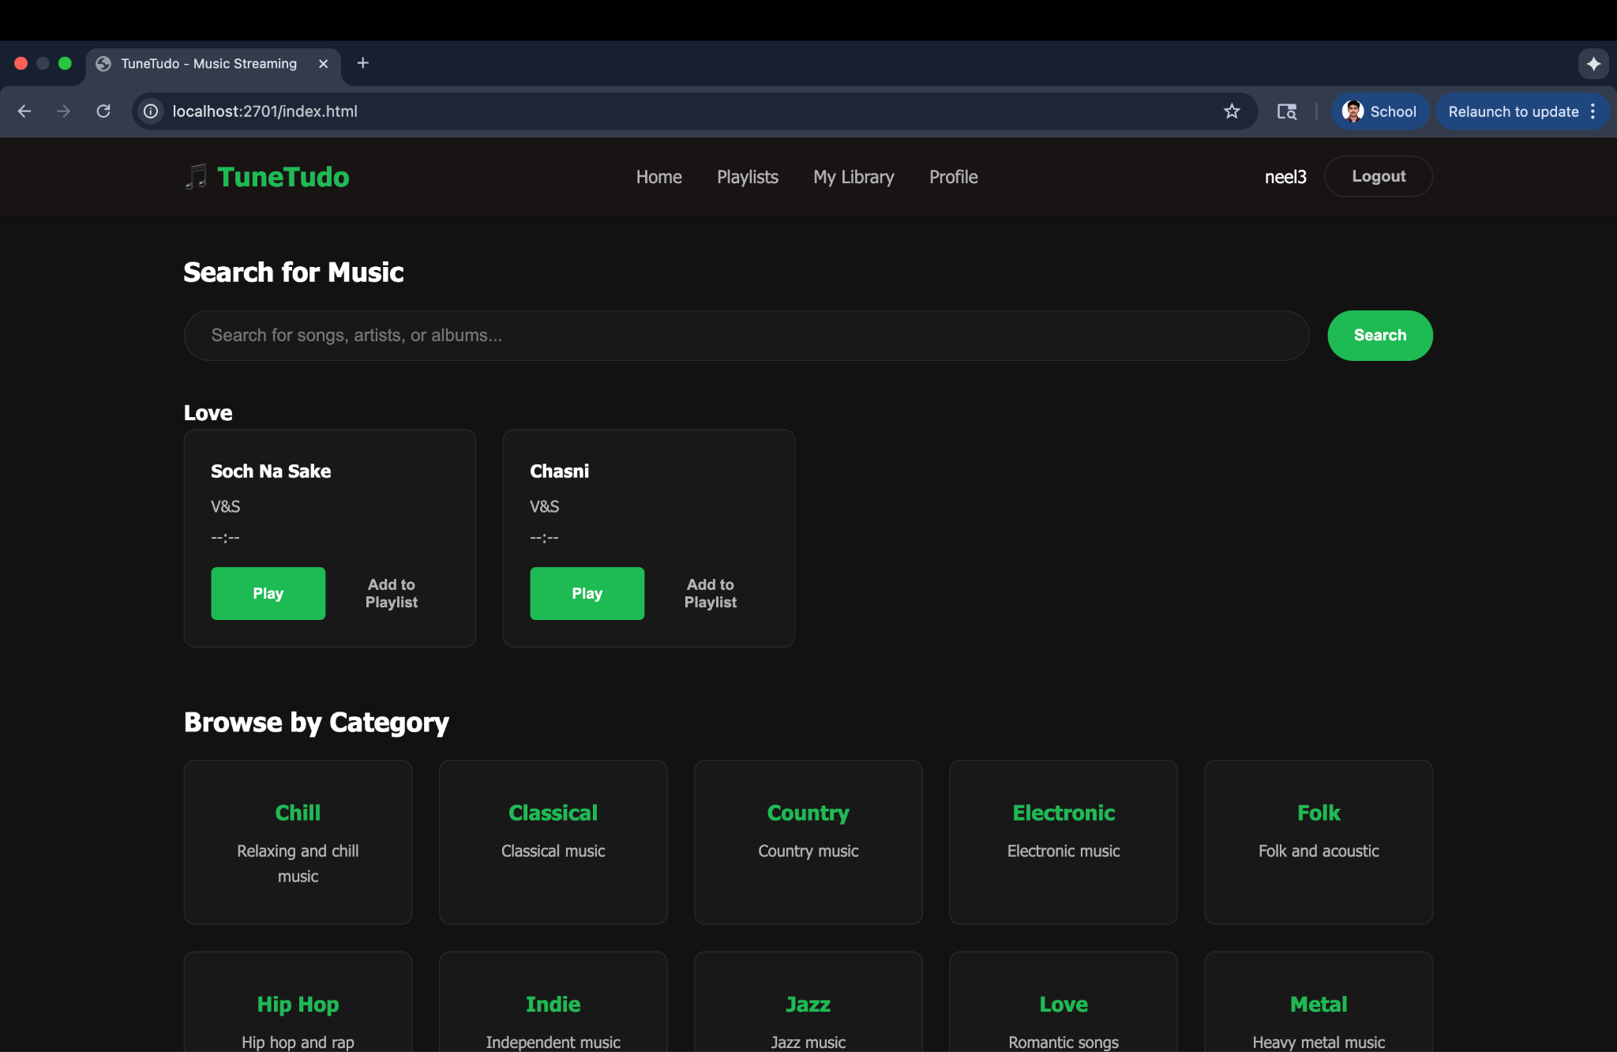

#### [**FR-006: Remove Song from Playlist**](https://docs.google.com/document/d/13fjih7UaoteZe9ls5Qn8RElRJIKu8S-Ocv_cmukeYYM/edit?tab=t.0#heading=h.wgff9zkw1ctw)

Pre-requisite: Add the song to a playlist as described in FR-003

Go to playlists page

Click on the playlist from which you want to remove the song.

Click the remove button next to the song  
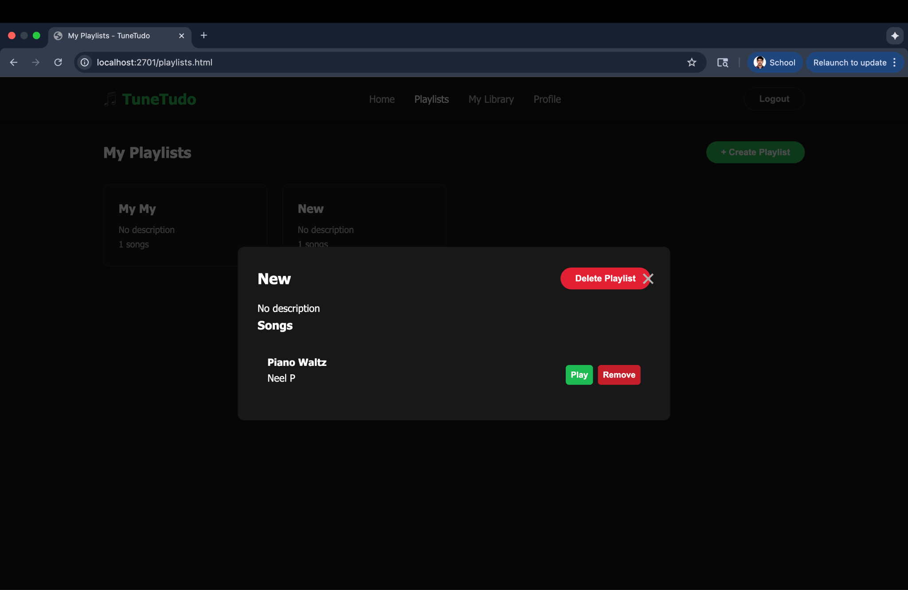

A popup message will appear asking for the confirmation.

Click “ok” to remove the song  
A confirmation message will appear that song has been removed.  
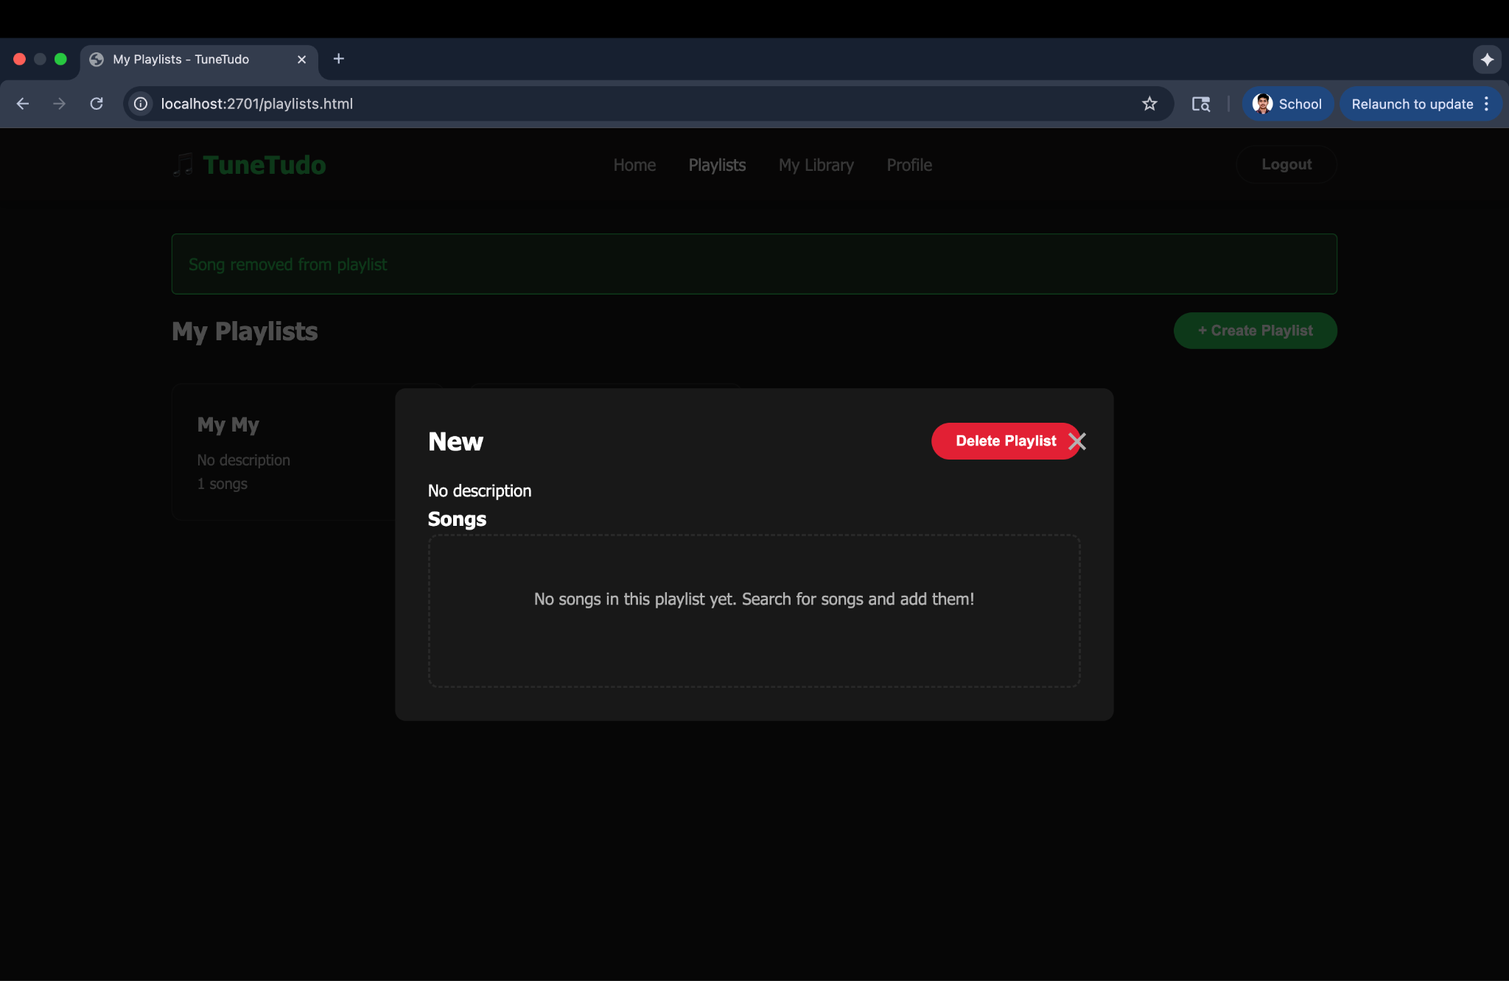

#### 

#### [**FR-007: Delete Playlist**](https://docs.google.com/document/d/13fjih7UaoteZe9ls5Qn8RElRJIKu8S-Ocv_cmukeYYM/edit?tab=t.0#heading=h.ljdona2uw0cc)

Go to playlists page.

Click on the playlist you want to delete.

Click the red coloured delete button.

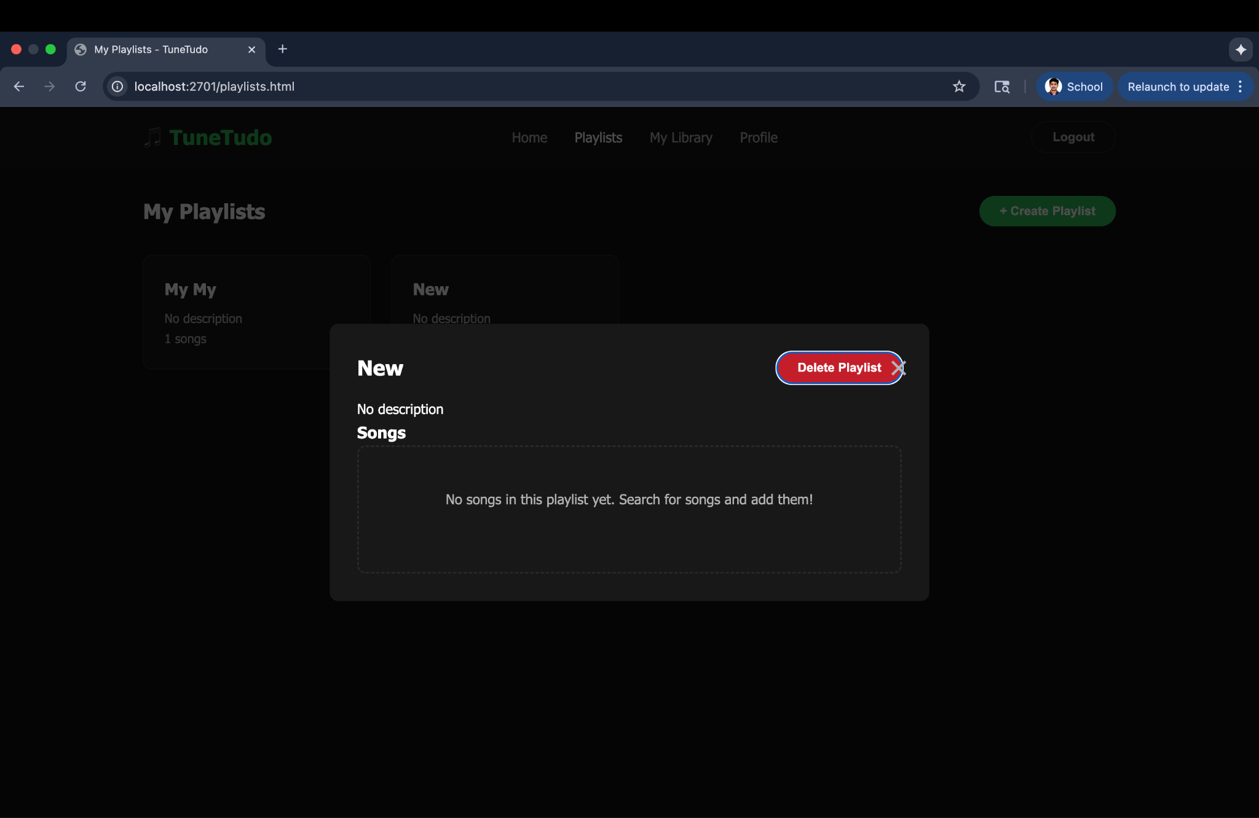  
A pop up message will appear asking for confirmation. Click ok to delete the playlist.

#### [**FR-008: User Upload Personal Tracks**](https://docs.google.com/document/d/13fjih7UaoteZe9ls5Qn8RElRJIKu8S-Ocv_cmukeYYM/edit?tab=t.0#heading=h.erpbzrghyu5f)

Pre-requisite: User must be logged in.

Go to My library page by clicking on the button appearing on the navigation bar.

Click on Upload Track button.

Select the audio file that you want to upload

Click Upload button.

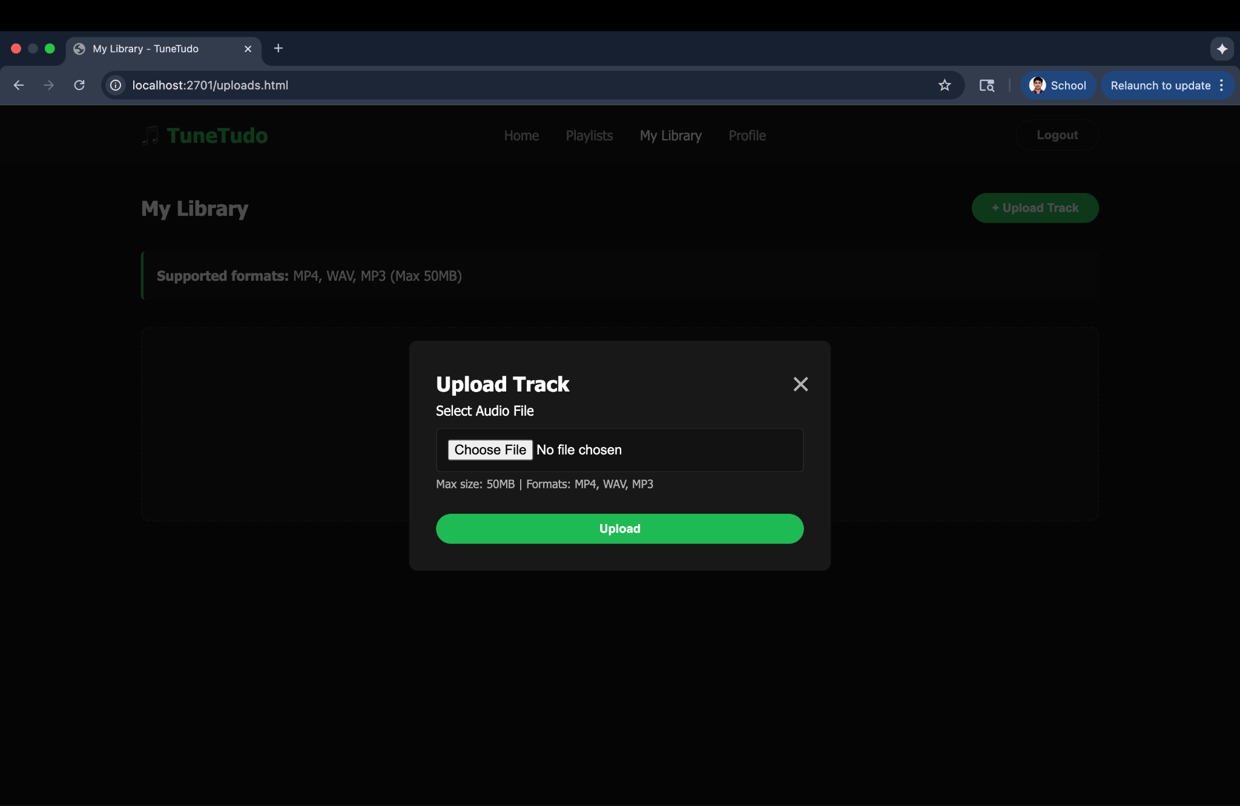

Song will be added to “My library”.

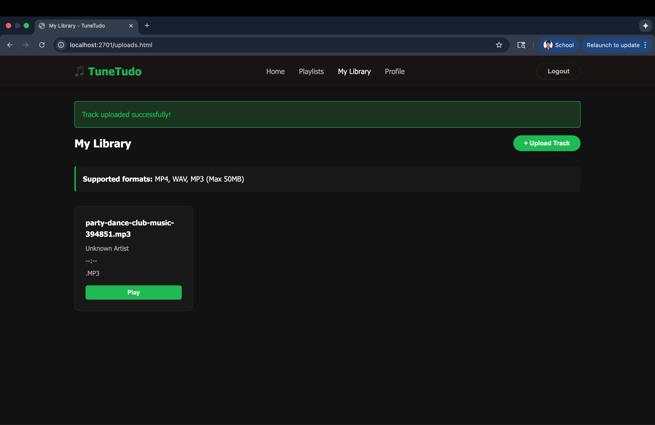

#### 

#### [**FR-009. Registration for First-Time Users**](https://docs.google.com/document/d/13fjih7UaoteZe9ls5Qn8RElRJIKu8S-Ocv_cmukeYYM/edit?tab=t.0#heading=h.d00prcpqsfjv)

Go to http:localhost:2701

Click on the top right Login button.

Click on the Register button(Don’t have an account? Register)

Enter username, email and password.

Click on the Register button.

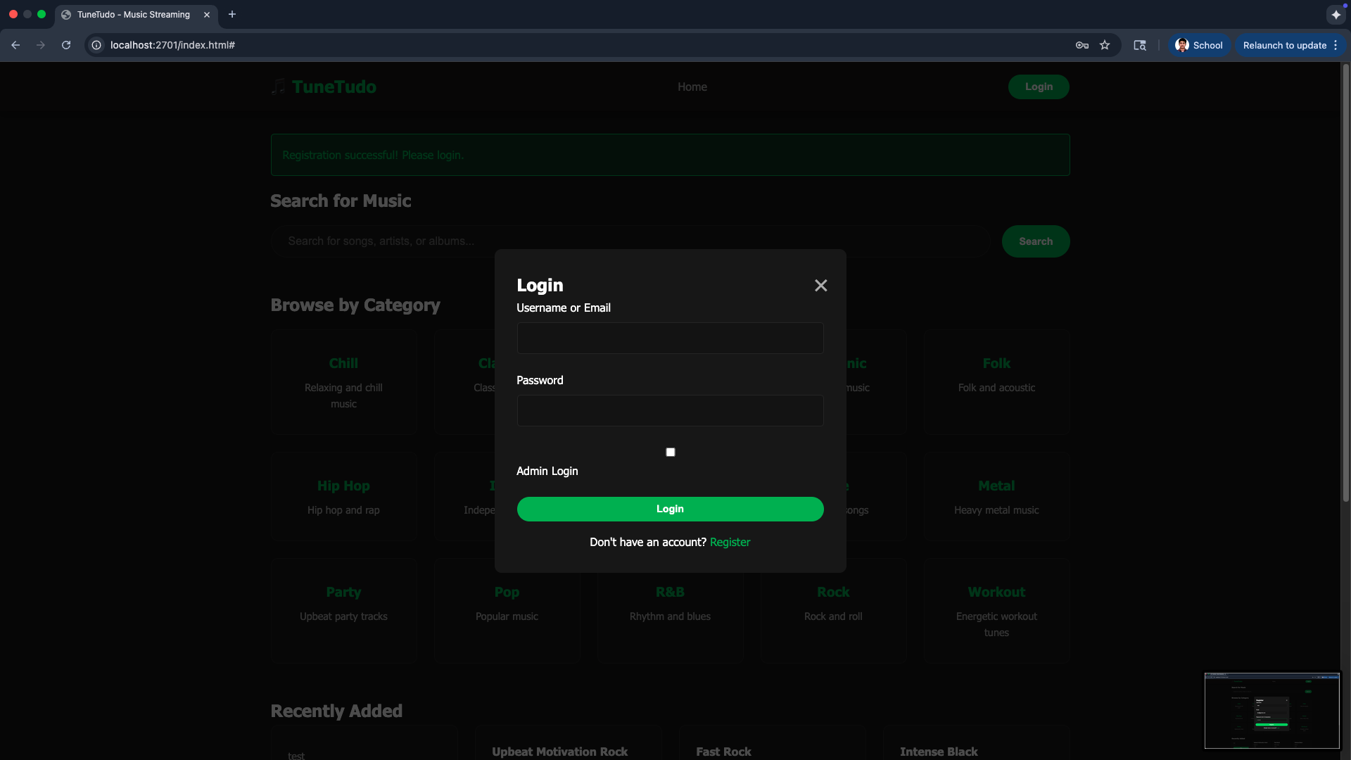

#### 

#### [**FR-010: Login for User**](https://docs.google.com/document/d/13fjih7UaoteZe9ls5Qn8RElRJIKu8S-Ocv_cmukeYYM/edit?tab=t.0#heading=h.91rkrgg231vf)

Go to <http://localhost:2701>

Click on top right Login Button

Enter credentials(username and password)

Click Login Button.

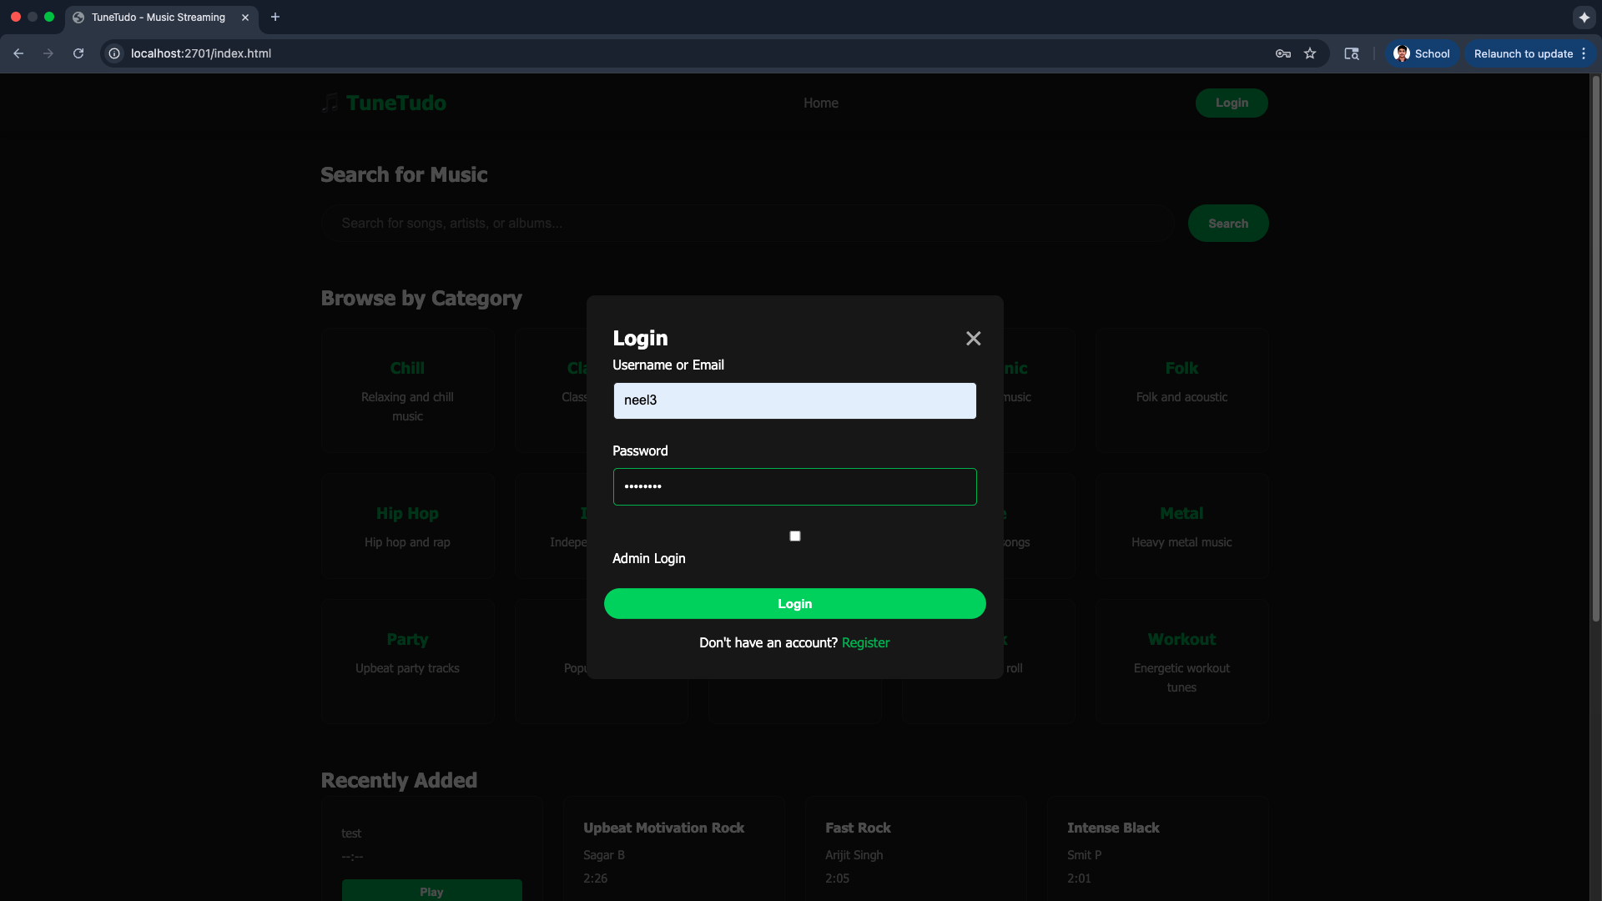

If the wrong username or password is entered, an error message will be displayed.

#### 

#### [**FR-011: User Upload Profile Picture**](https://docs.google.com/document/d/13fjih7UaoteZe9ls5Qn8RElRJIKu8S-Ocv_cmukeYYM/edit?tab=t.0#heading=h.qsqqr0zb5vav)

After logging in successfully.

Click on Profile button from the navigation menu.

Click on Change Picture button appearing in the Profile Picture card

Select the image and click Upload Picture button.  
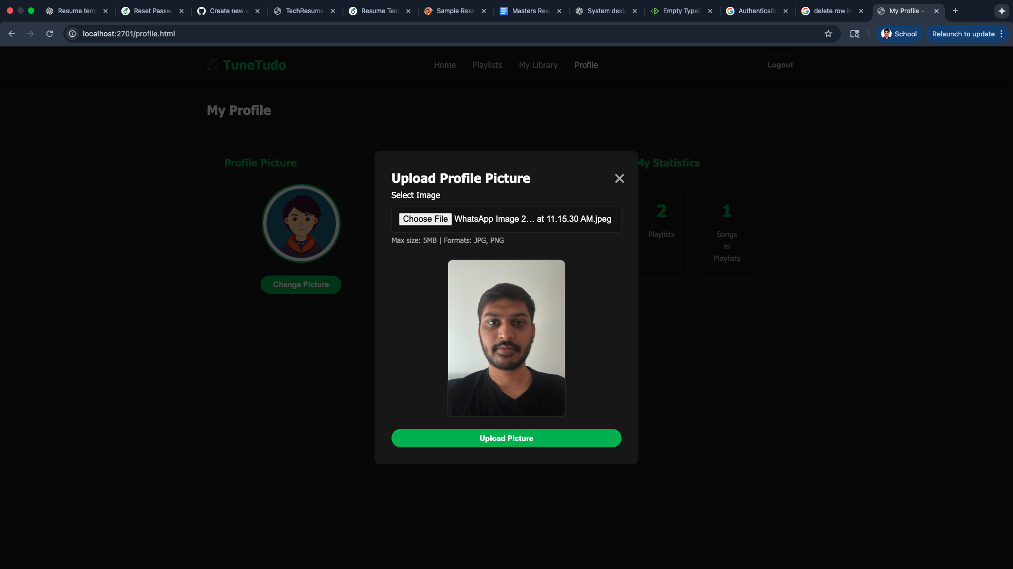

#### 

#### [**FR-012. Login for Admins**](https://docs.google.com/document/d/13fjih7UaoteZe9ls5Qn8RElRJIKu8S-Ocv_cmukeYYM/edit?tab=t.0#heading=h.bib71c4qkjxk) Go to <http://localhost:2701>

Click on top right Login Button

Enter credentials(username and password)  
Select the Admin Login Checkmark button.

Click Login Button.  
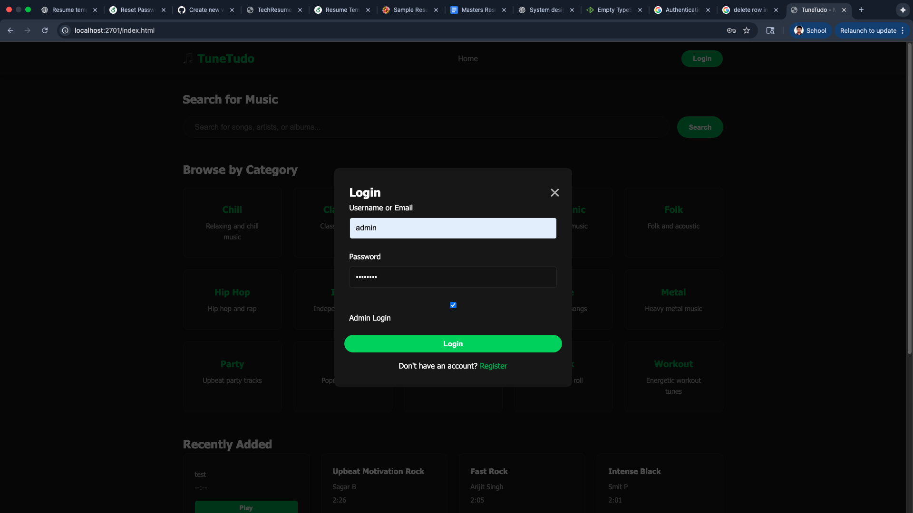  
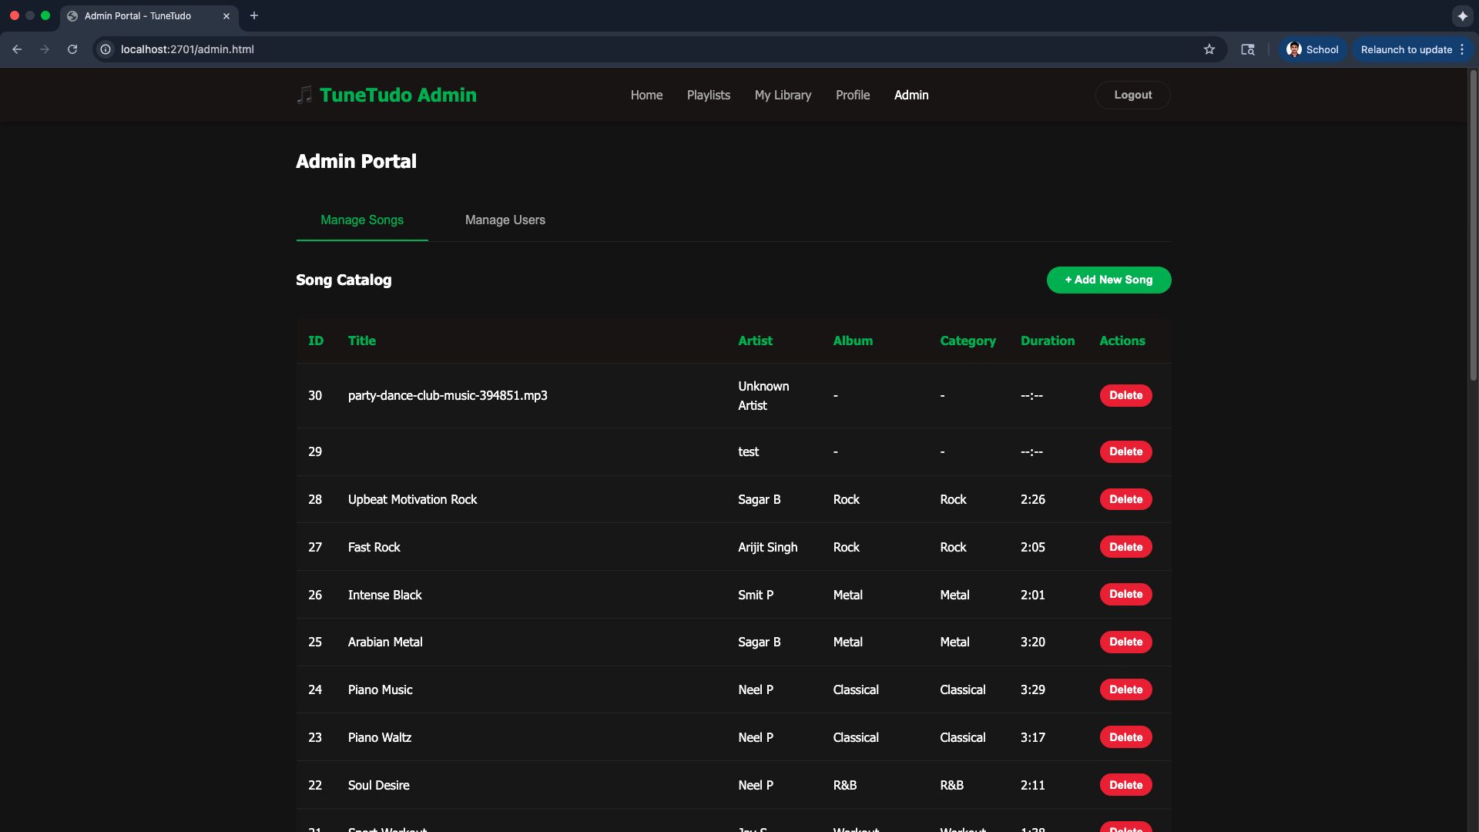

If the user has admin privileges then Admin Login will be successful otherwise an error message will appear.

#### 

#### [**FR-013: Admin Upload New Song**](https://docs.google.com/document/d/13fjih7UaoteZe9ls5Qn8RElRJIKu8S-Ocv_cmukeYYM/edit?tab=t.0#heading=h.s9en0qqtoi04)

Login as an Admin.

Go to Admin Page

Click on Add New Song

Select the audio file from local disk and fill songs metadata like Song Title, Artist Name, Album Name, etc  
Click on “Add Song to Catalog” button.

Song will be added to the user’s catalog.

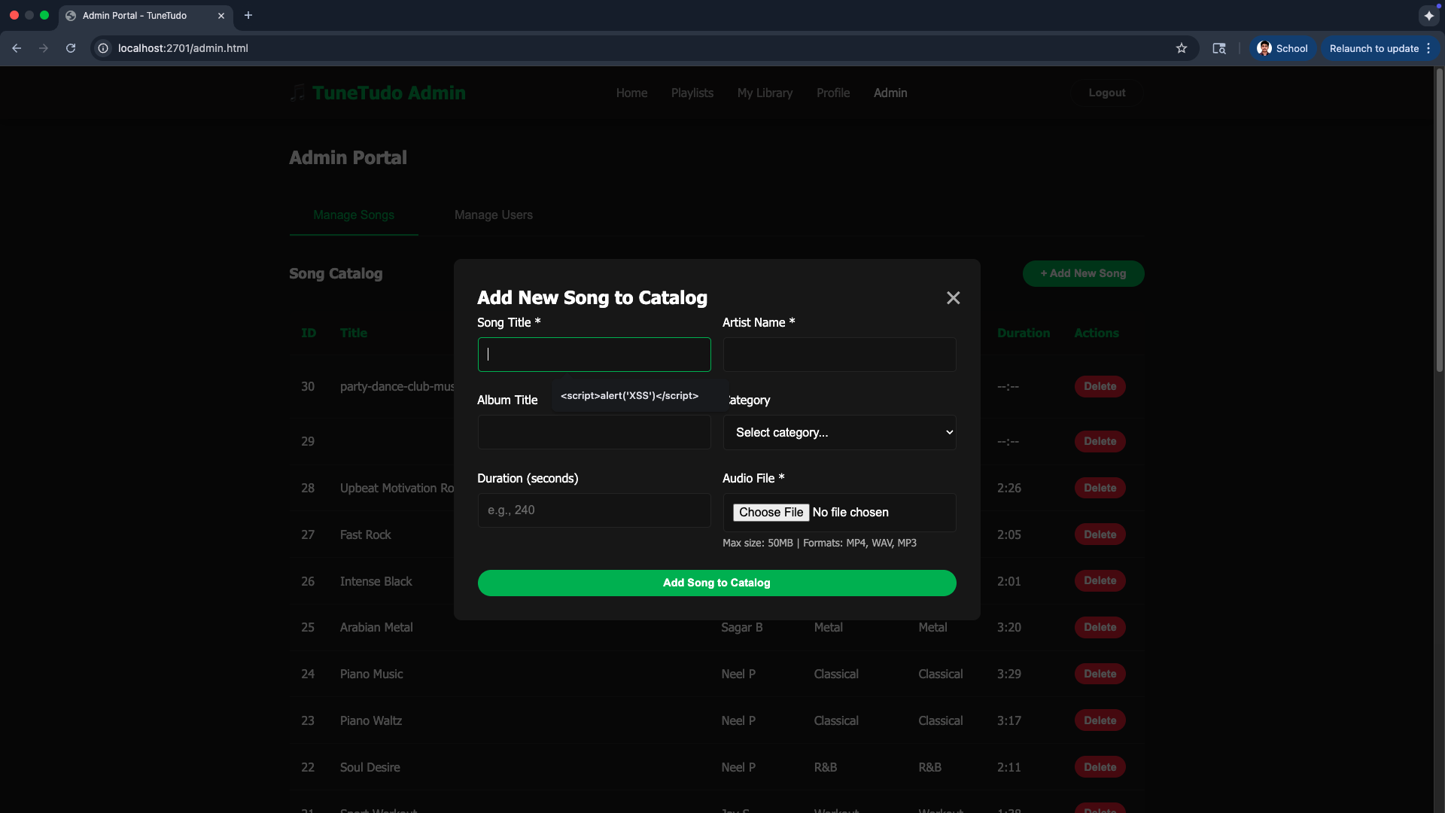

#### 

#### [**FR-014. Logout FRs (User + Admin)**](https://docs.google.com/document/d/13fjih7UaoteZe9ls5Qn8RElRJIKu8S-Ocv_cmukeYYM/edit?tab=t.0#heading=h.xlda28shyxut)

Click on the logout button on the top right.

User/Admin will be logged out.

### Use Cases

All the five use cases mentioned in the Phase 1 are covered in the functional requirements FR-001 to FR-014  
[Use Case 1: Search and Play Music](https://docs.google.com/document/d/1hmbj6YB7Pd93kDuP4AZMUM1LQdxUipwZD0bYonf0AmI/edit?tab=t.0#heading=h.np27n0riq6x)

[Use Case 2: Manage Playlists](https://docs.google.com/document/d/1hmbj6YB7Pd93kDuP4AZMUM1LQdxUipwZD0bYonf0AmI/edit?tab=t.0#heading=h.7mrvfi94rjs3)

[Use Case 3: Manage Personal Library and Profile](https://docs.google.com/document/d/1hmbj6YB7Pd93kDuP4AZMUM1LQdxUipwZD0bYonf0AmI/edit?tab=t.0#heading=h.hwrd63e3ufq)

[Use Case 4: User Account Management](https://docs.google.com/document/d/1hmbj6YB7Pd93kDuP4AZMUM1LQdxUipwZD0bYonf0AmI/edit?tab=t.0#heading=h.rsta53ojsfoy)

[Use Case 5: Admin Management](https://docs.google.com/document/d/1hmbj6YB7Pd93kDuP4AZMUM1LQdxUipwZD0bYonf0AmI/edit?tab=t.0#heading=h.rsh7t0dfz9af)

### Troubleshooting Common Issues

#### Common Issues

##### Issue: Port Already in Use

****Error: listen tcp :2701: bind: address already in use

##### Solution:

****# Find process using port 2701

lsof -i :2701 # macOS/Linux

netstat -ano | findstr :2701 # Windows

# Kill the process

kill -9 <PID> # macOS/Linux

taskkill /PID <PID> /F # Windows

# Or change port in .env

PORT=8080

##### Issue: Database Locked

Error: database is locked

##### Solution:

****# Stop all instances

pkill tunetudo

# Remove lock

rm tunetudo.db-wal

rm tunetudo.db-shm

# Restart

go run main.go

##### Issue: Module Not Found

****Error: cannot find module

##### Solution:

****go mod download

go mod tidy

go mod verify

##### Issue: Permission Denied (Linux)

****Error: permission denied

##### Solution:

****# Make binary executable

chmod +x tunetudo

# Fix storage permissions

chmod -R 755 storage/

##### Issue: SQLite Not Found

****Error: sqlite3: not found

##### Solution:

# macOS

brew install sqlite3

# Linux

sudo apt-get install sqlite3 libsqlite3-dev

# Rebuild

go clean

go build

#### Enable Debug Logging

Add to main.go (temporarily):

app.Use(logger.New(logger.Config{

Format: "[${time}] ${status} - ${method} ${path} - ${latency}\n",

}))

#### Check System Resources

****# Check disk space

df -h

# Check memory

free -h # Linux

top # macOS

# Check running processes

ps aux | grep tunetudo

#### Verify File Permissions

****# Check project permissions

ls -la

# Fix if needed

chmod -R 755 .

chmod +x tunetudo



### Security Features

#### Input Validation

##### Putting malicious input in search field(SQL Injection Attack Prevention)

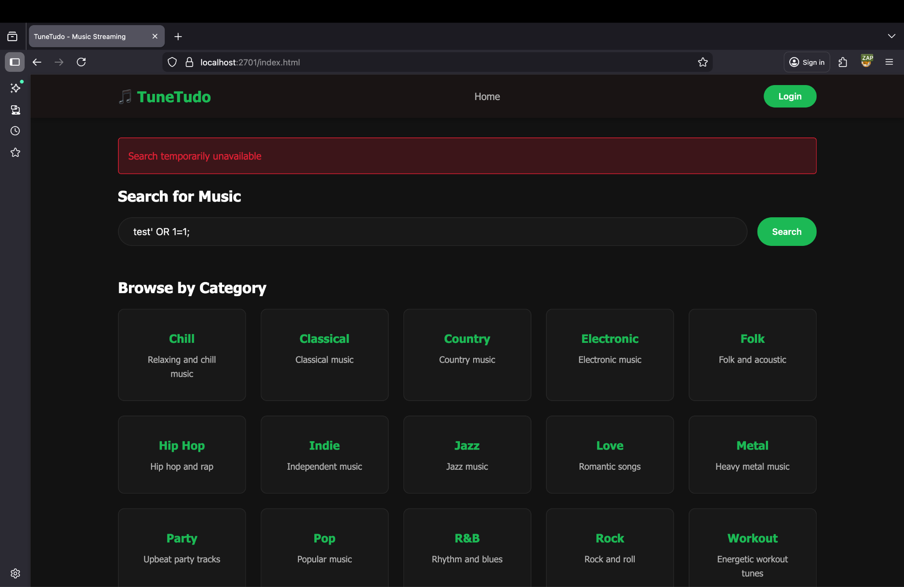

We get error message that search temporarily unavailable

This shows that input validation is in place.

##### Uploading large track file(

When we try to upload a large file(>50MB) then we get error message

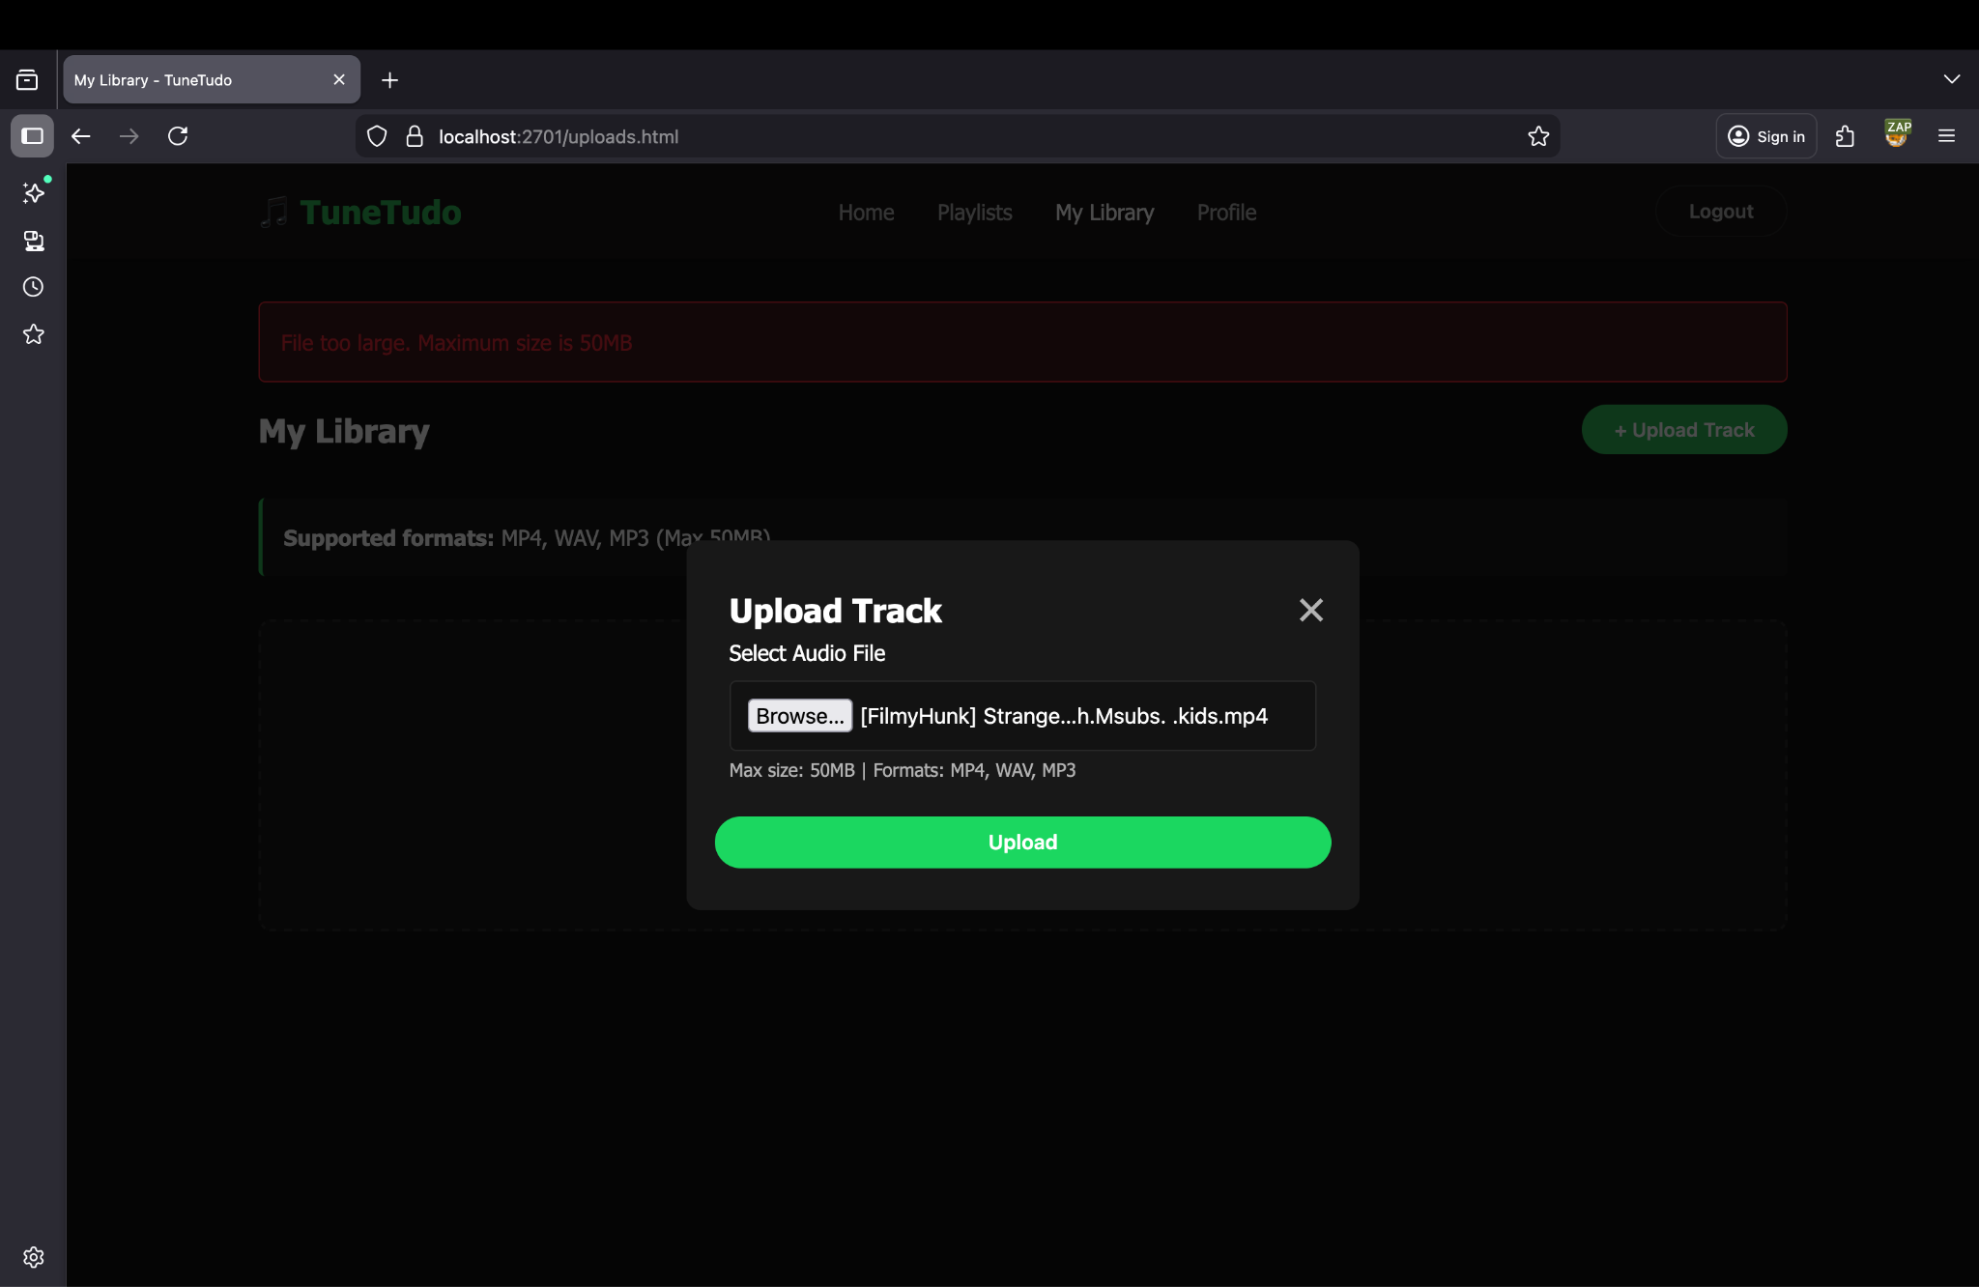

This shows that input validation on file size is in place. Further, it does not allow you to upload any other file apart from mp4, wav and mp3.

##### XSS Attack Protection

Further, no XSS attack is possible try to inject malicious script:  
<script>alert('XSS');</script>

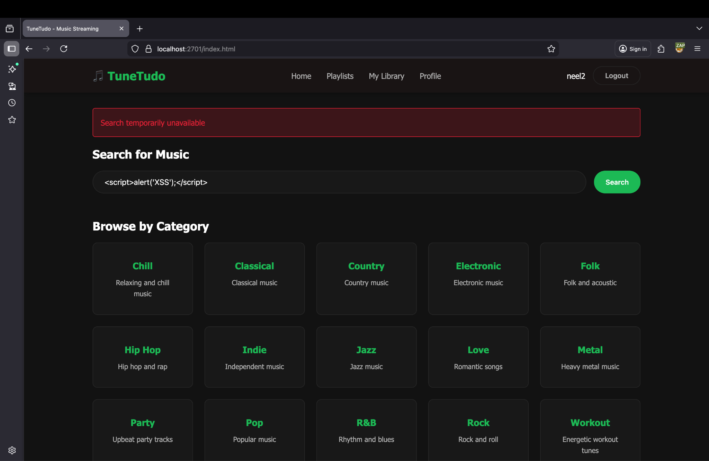

#### Cryptography

##### Bcrypt Algorithm for Password Hashing

We have use bcrypt module for generating password hashes which is considered as a secure algorithm.

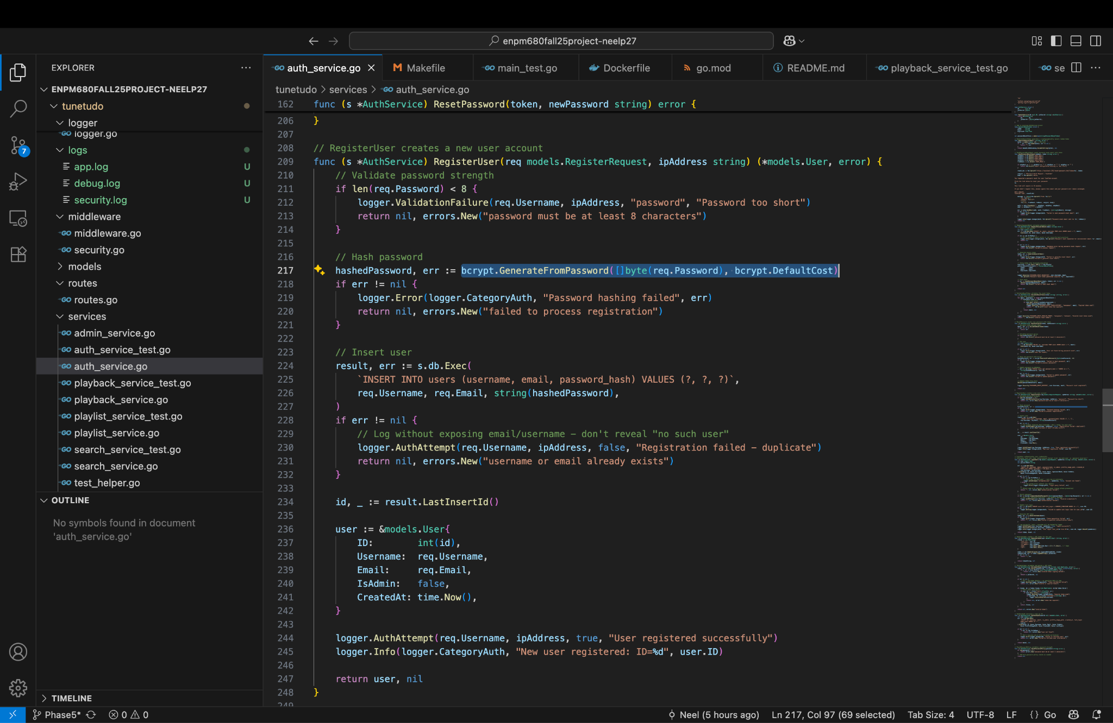

##### Forgot Password Mechanism Implemented Securely

In application, the forgot password mechanism is implemented securely, the person will get the link in their registered email id to reset the password

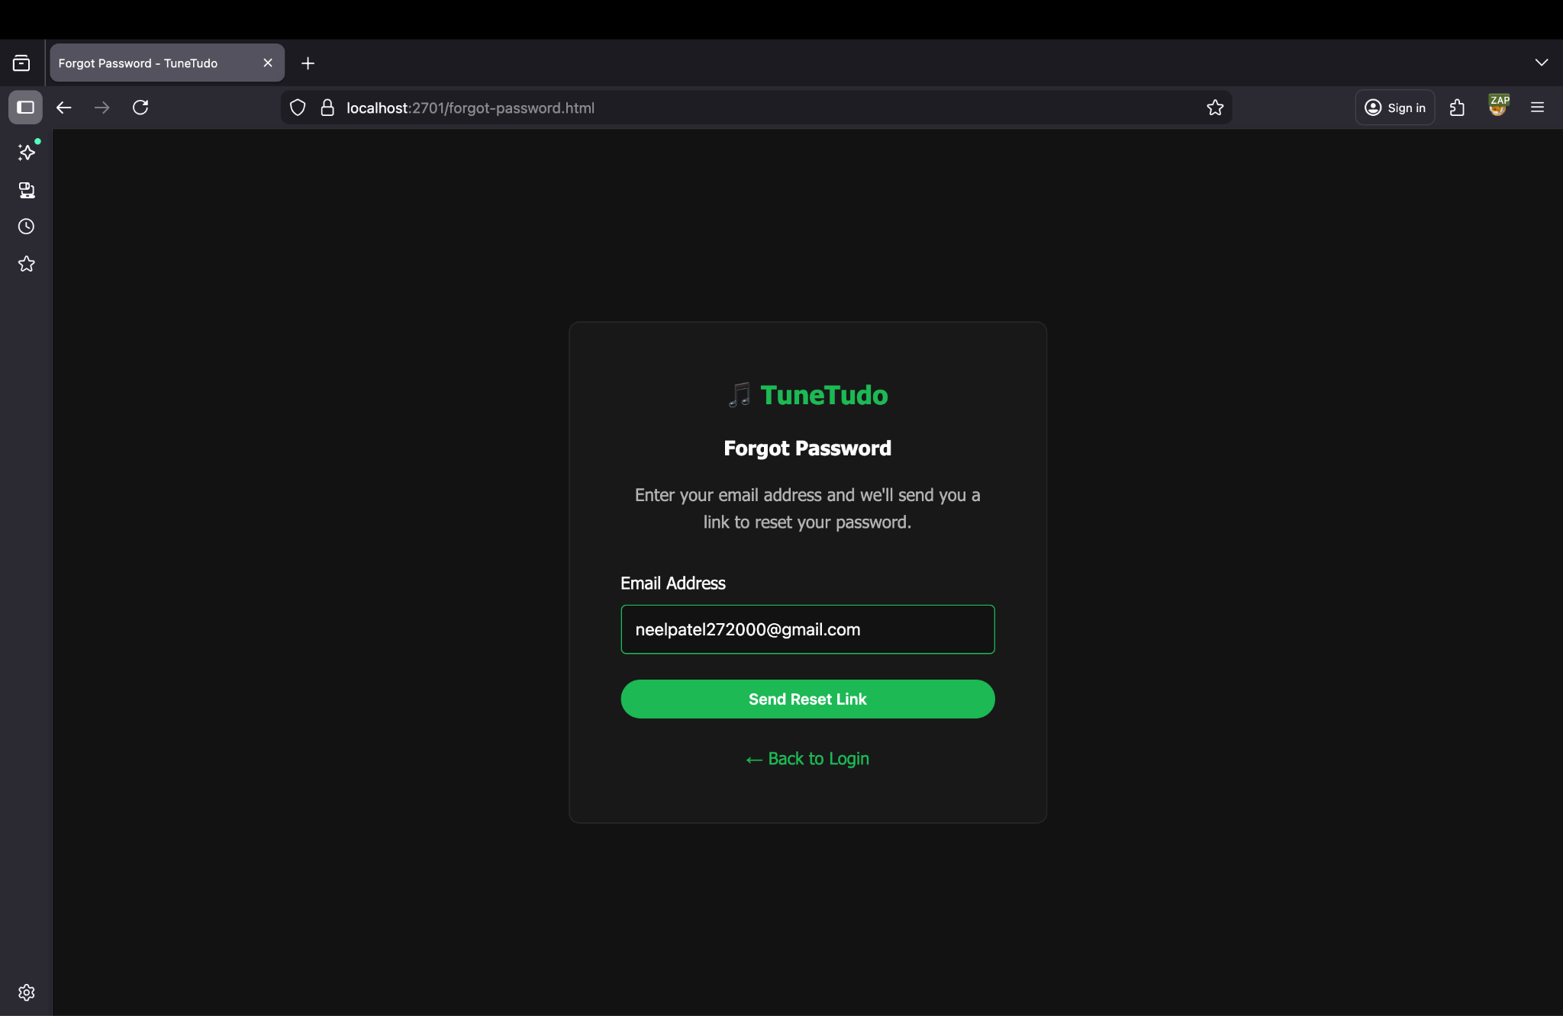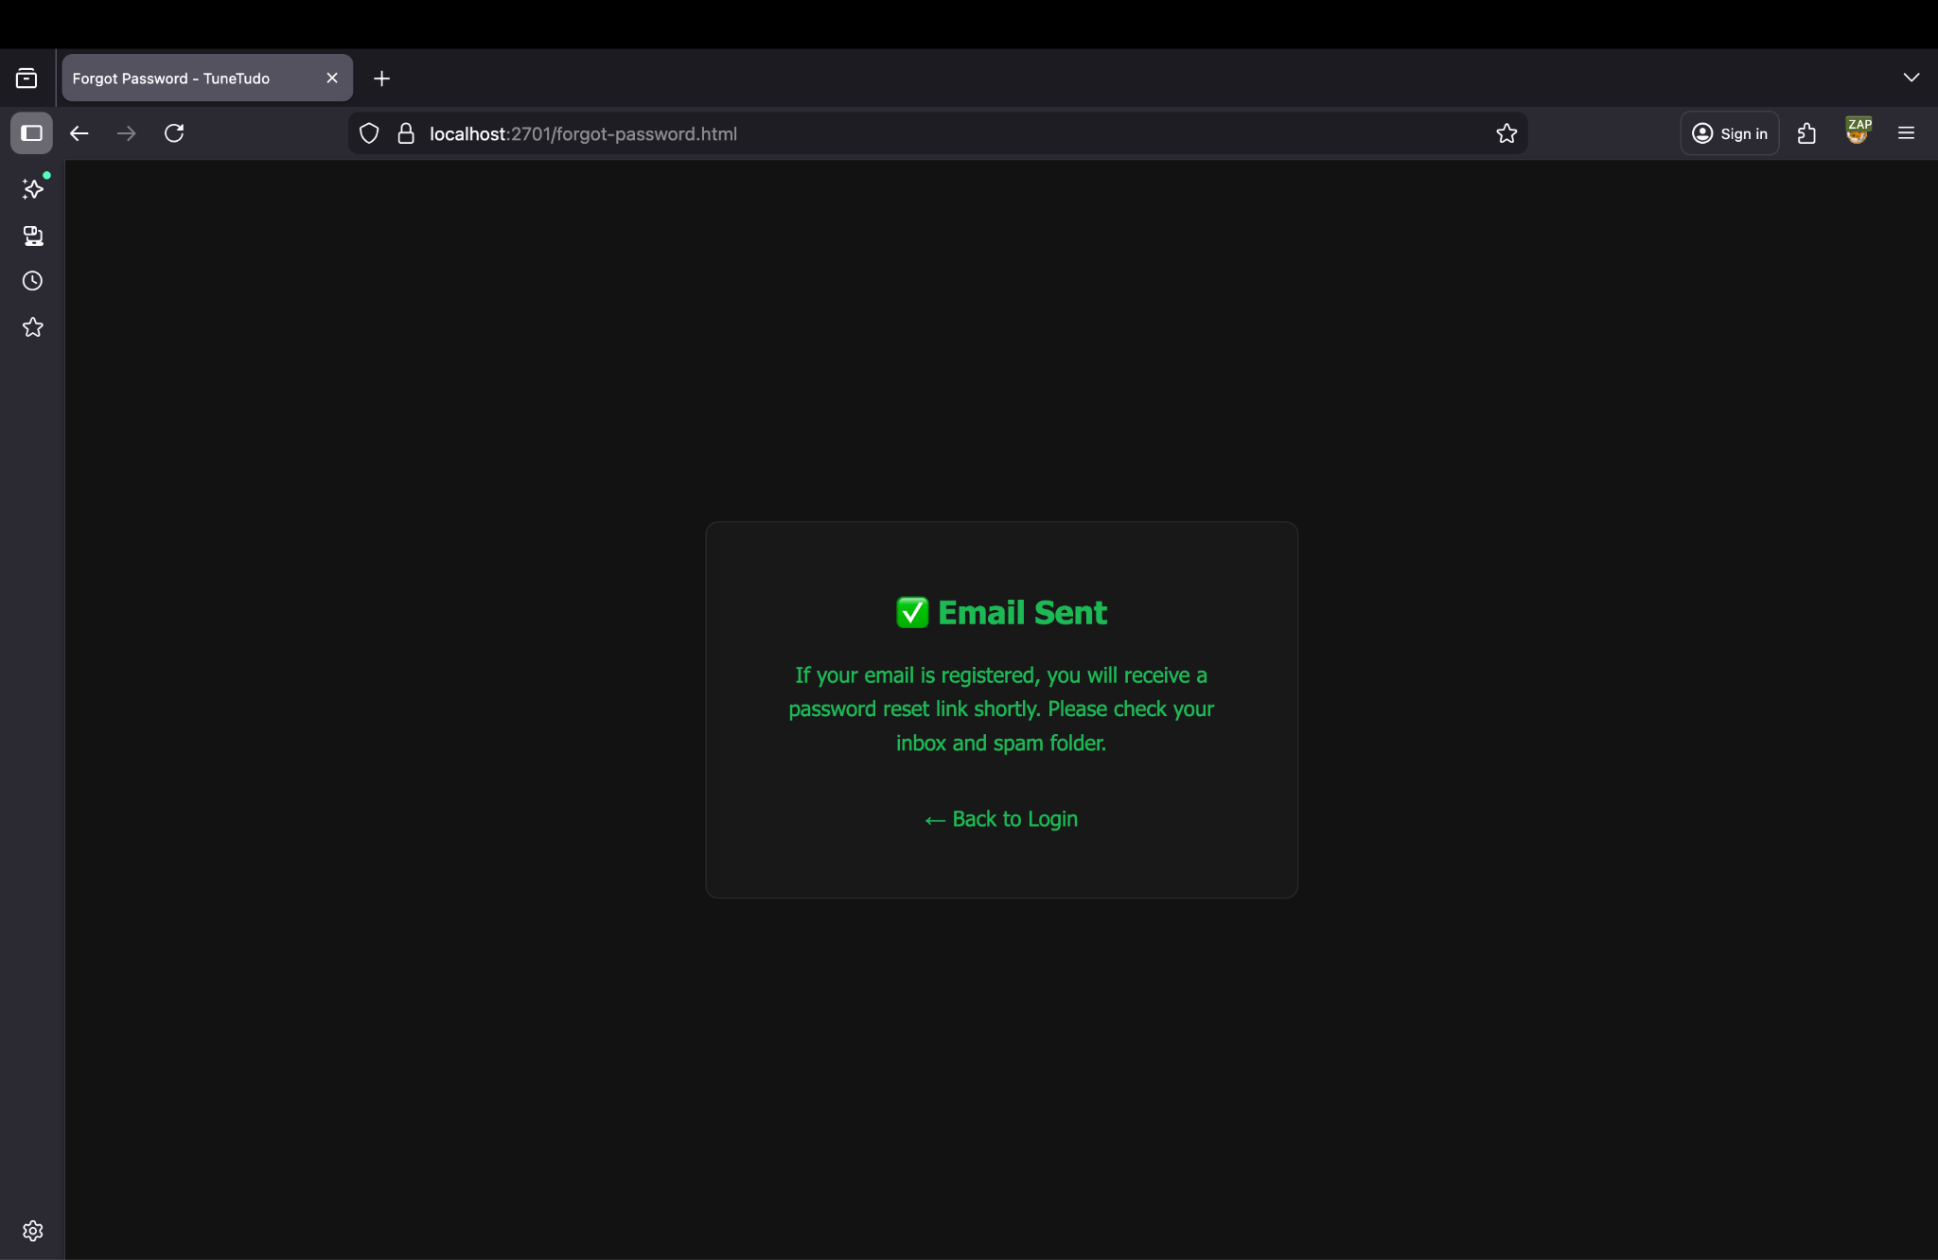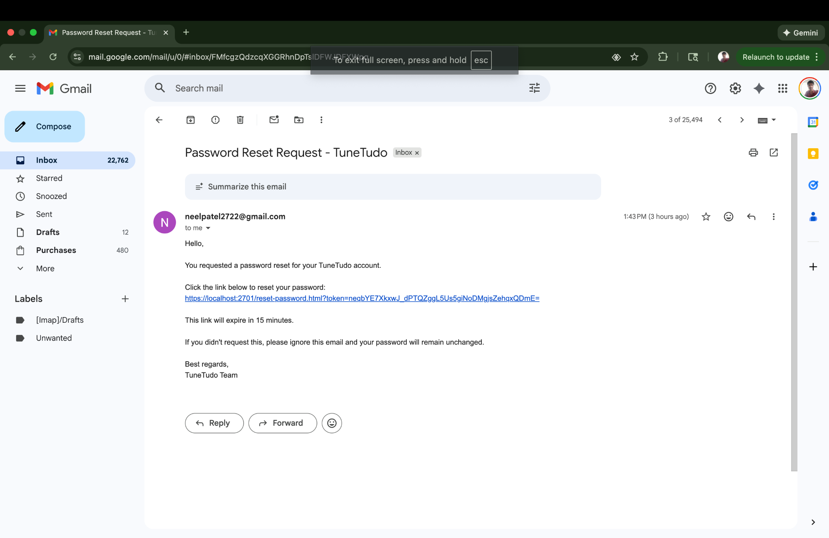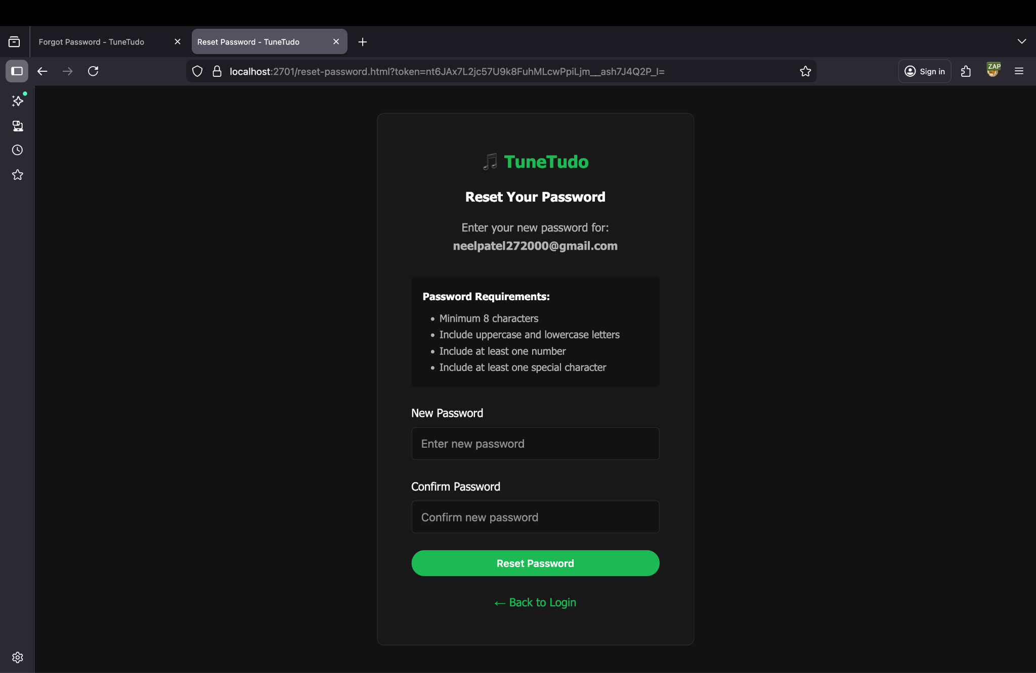

##### HTTPS WITH TLS

 // TLS configuration

certicateFile := os.Getenv("TLS_CERT_FILE")

keyFile := os.Getenv("TLS_KEY_FILE")

log.Printf("Using TLS cert: %s and key: %s", certicateFile, keyFile)

if certicateFile == "" || keyFile == "" {

logger.Error(logger.CategoryAPI, "TLS certificate or key file not specified in environment variables", nil)

log.Fatal("TLS certificate or key file not specified in environment variables")

}

go func() {

http.HandleFunc("/", func(w http.ResponseWriter, r *http.Request) {

target := "https://" + r.Host + r.URL.RequestURI()

// redirect to HTTPS

if r.Host == "localhost:2701" {

target = "https://localhost:2701" + r.URL.RequestURI()

}

http.Redirect(w, r, target, http.StatusMovedPermanently)

})

if err := http.ListenAndServe(":" + cfg.Port, nil); err != nil {

fmt.Printf("HTTP redirect server stopped due to: %v\n", err)

}

}()

if err := app.ListenTLS(":" + cfg.Port, certicateFile, keyFile); err != nil {

logger.Error(logger.CategoryAPI, "Server failed to start", err)

log.Fatalf("Failed to start the TLS server: %v", err)

}

I have used the HTTPS protocol with TLS to ensure secure data transport.

#### Authentication and Authorization

The authentication and authorization is also taken care of. Users can only perform admin activities if he/she has admin privileges.

If the user is not admin and tries to visit admin page, gets the error message

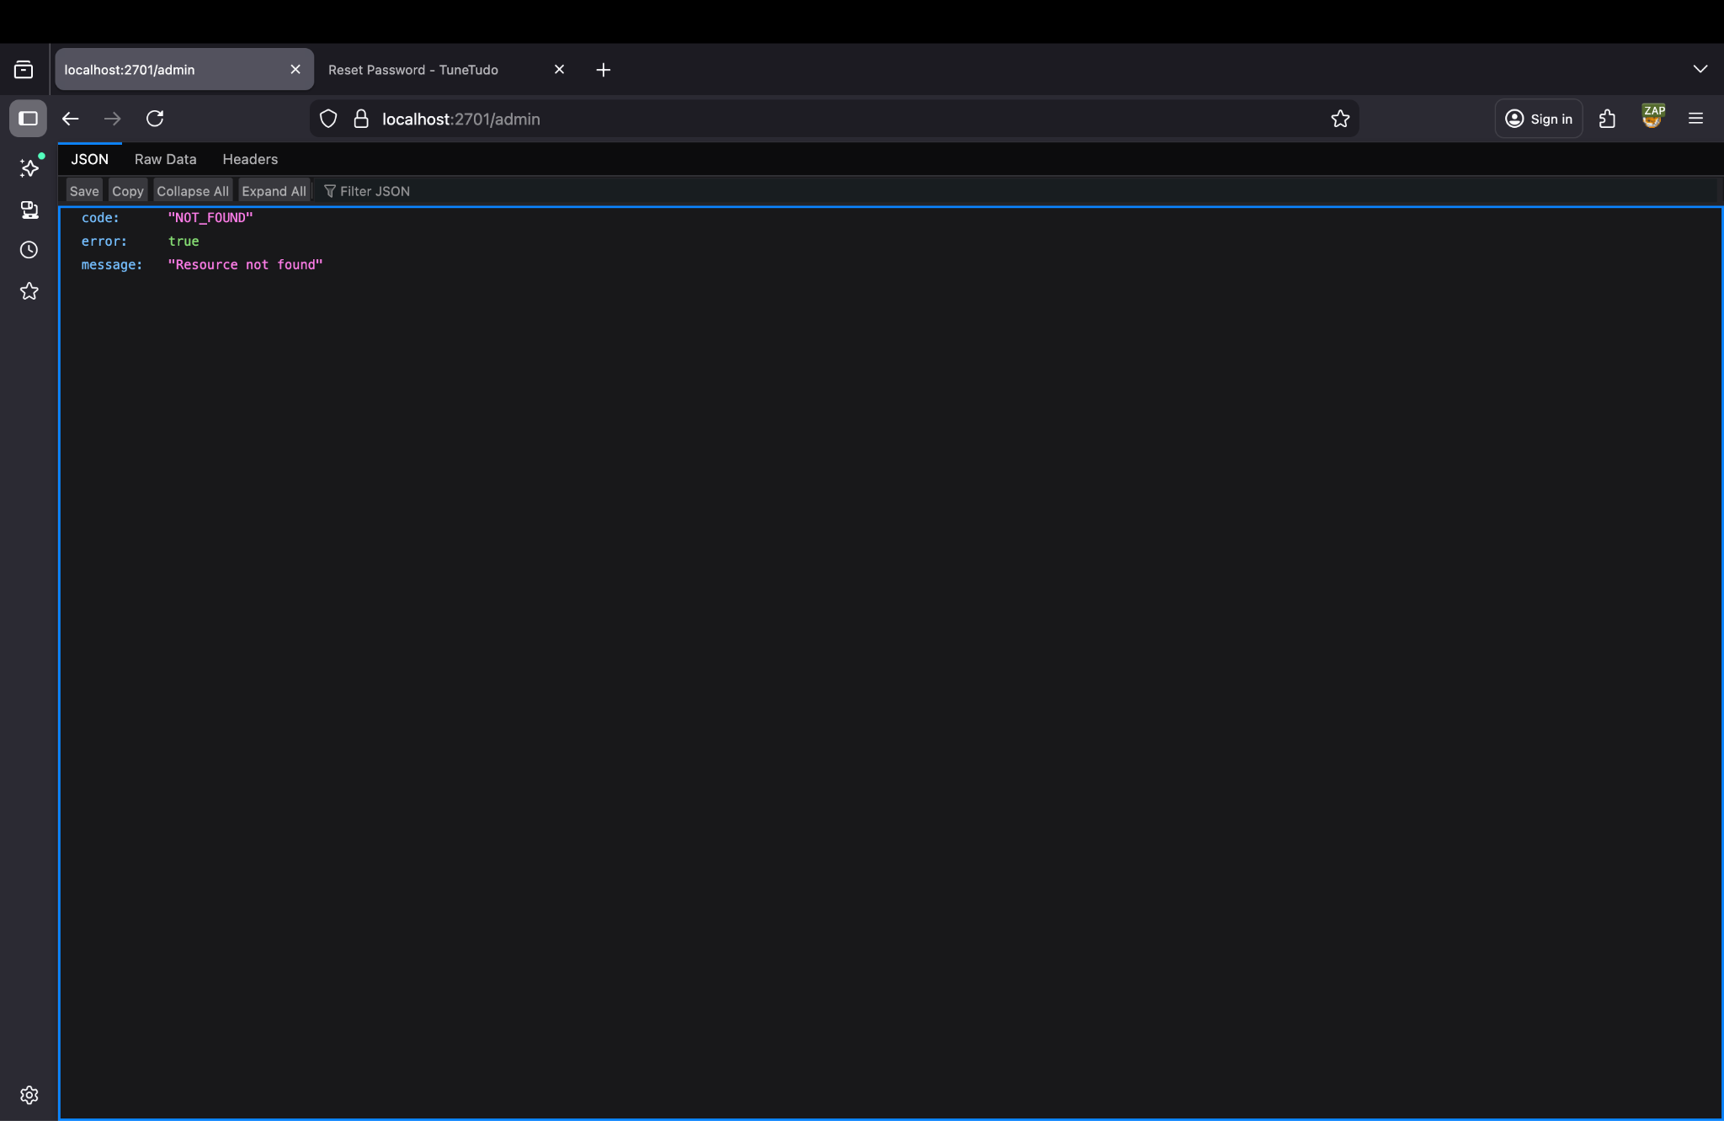

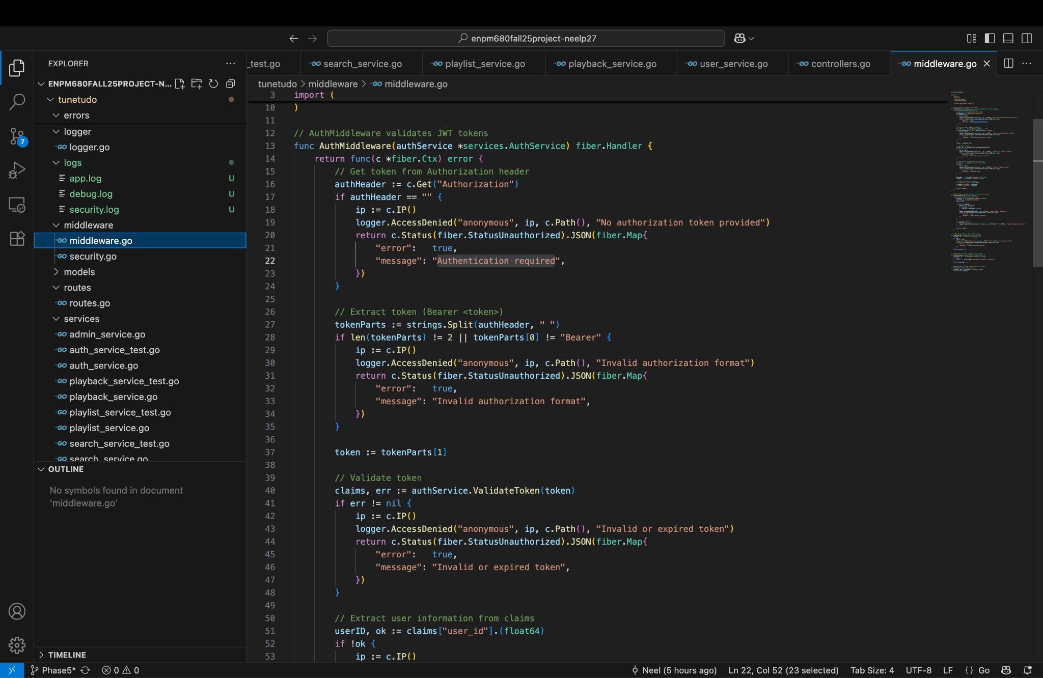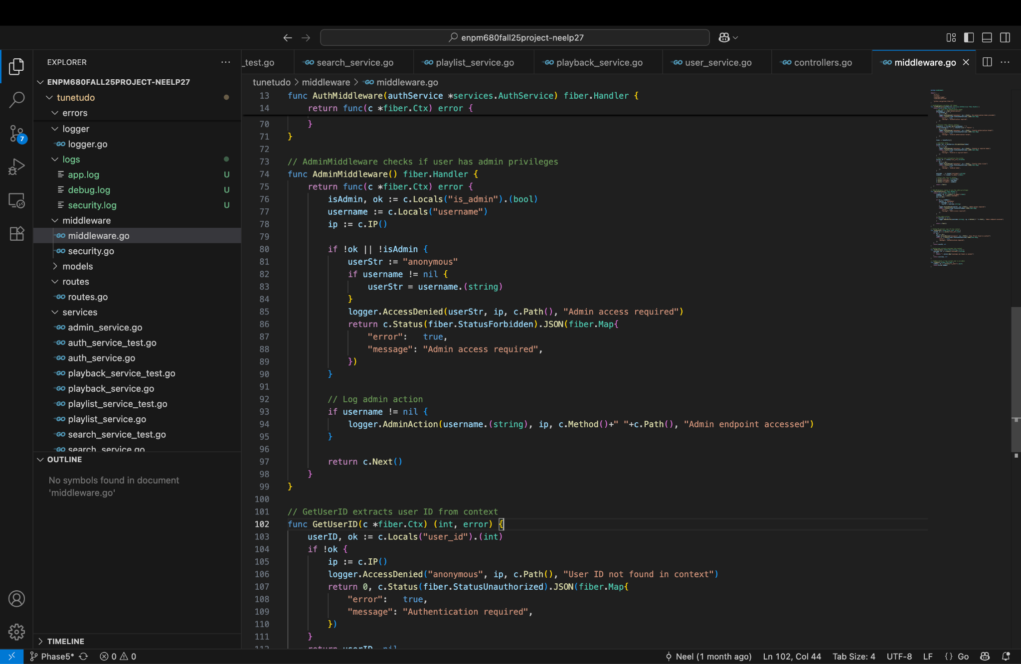

##### Rate Limiting

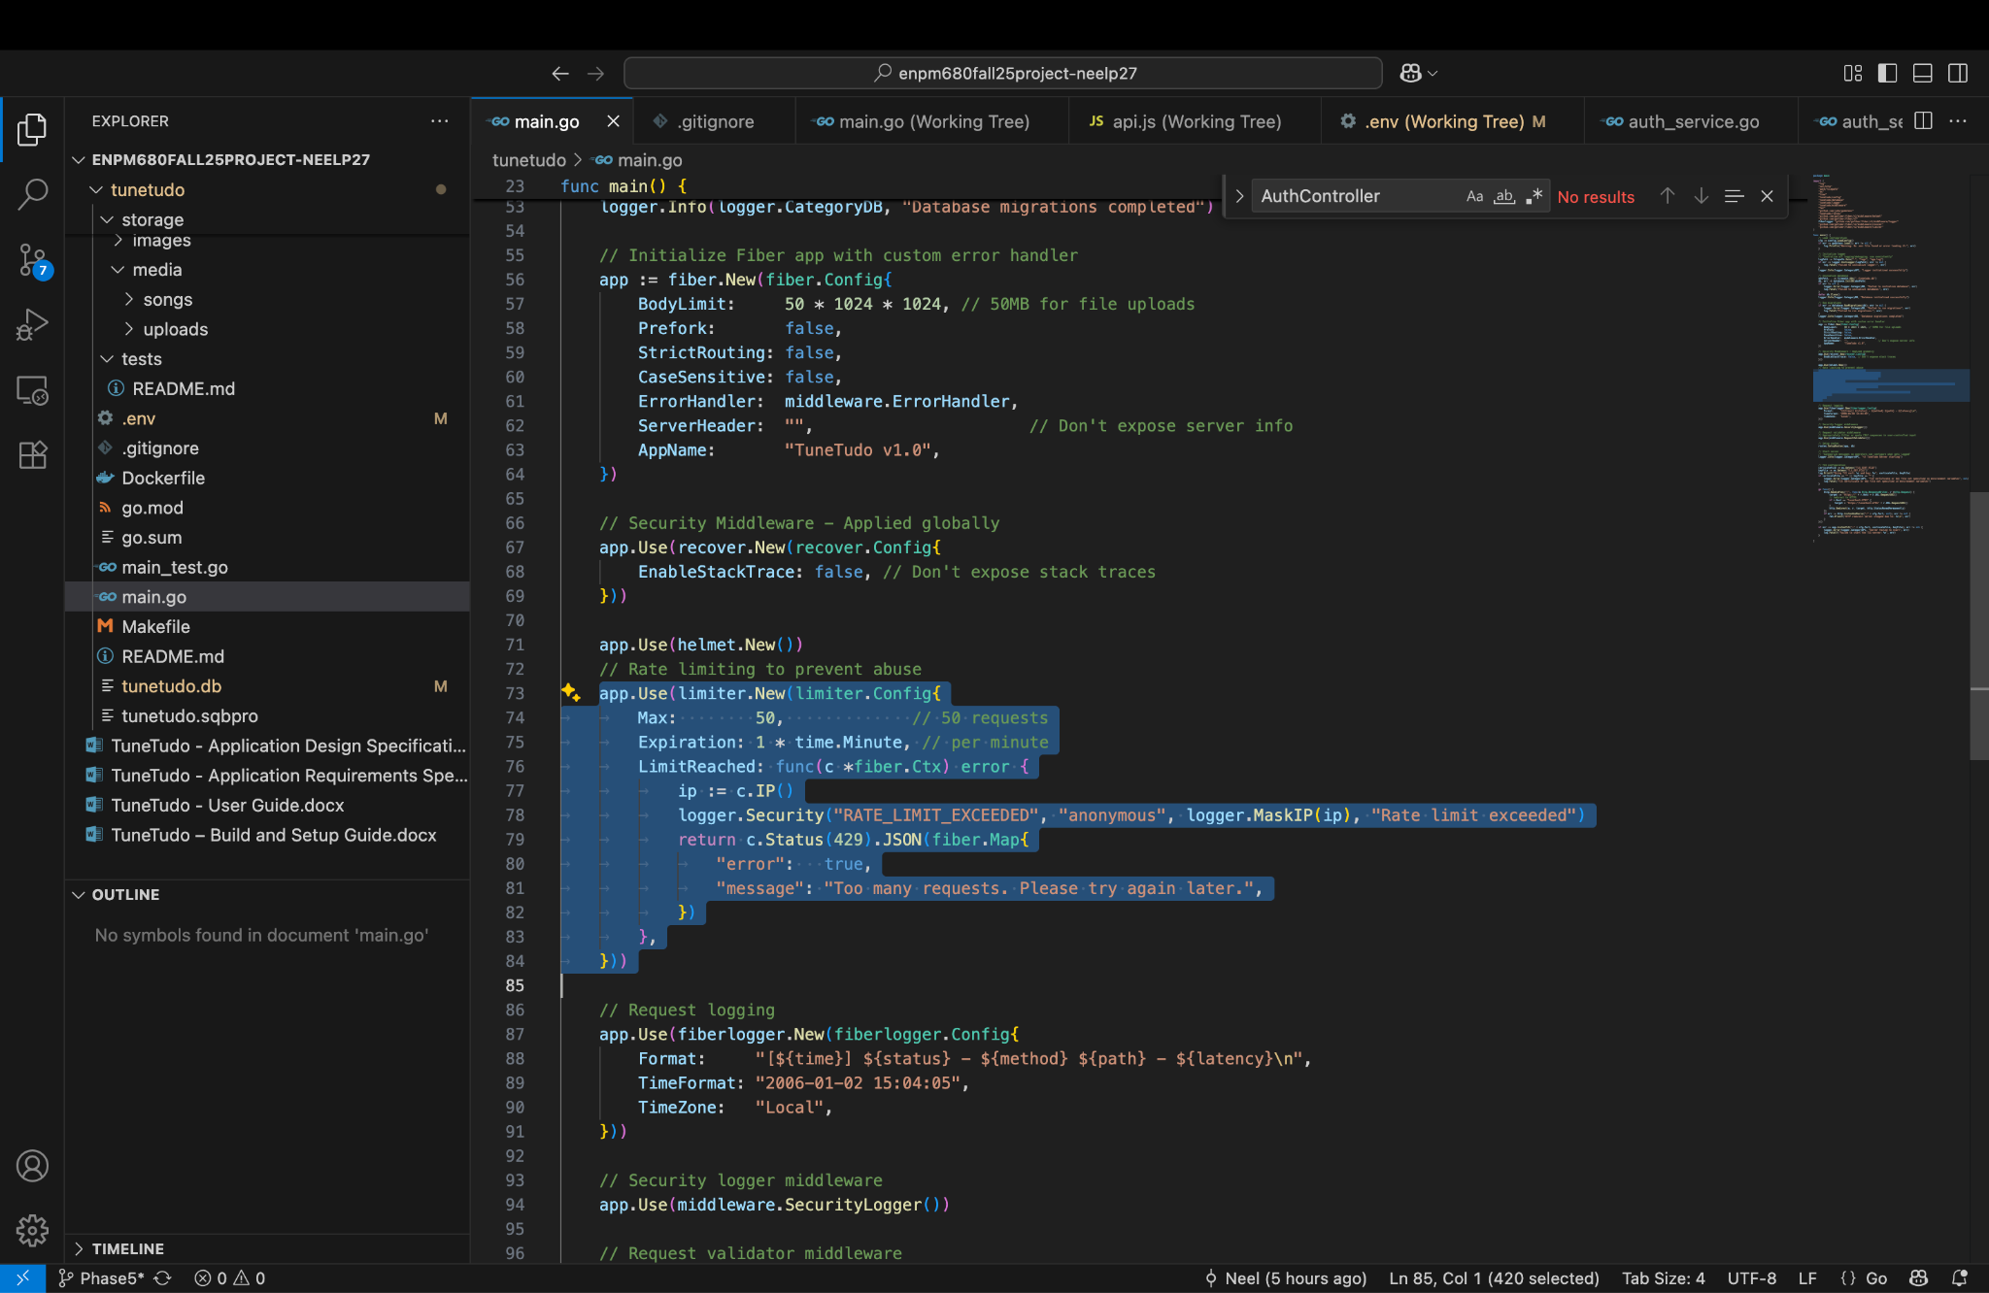

Rate limiter is also enabled so that DOS attack cannot be performed

#### Session Management

JWT tokens are used in order to manage the sessions

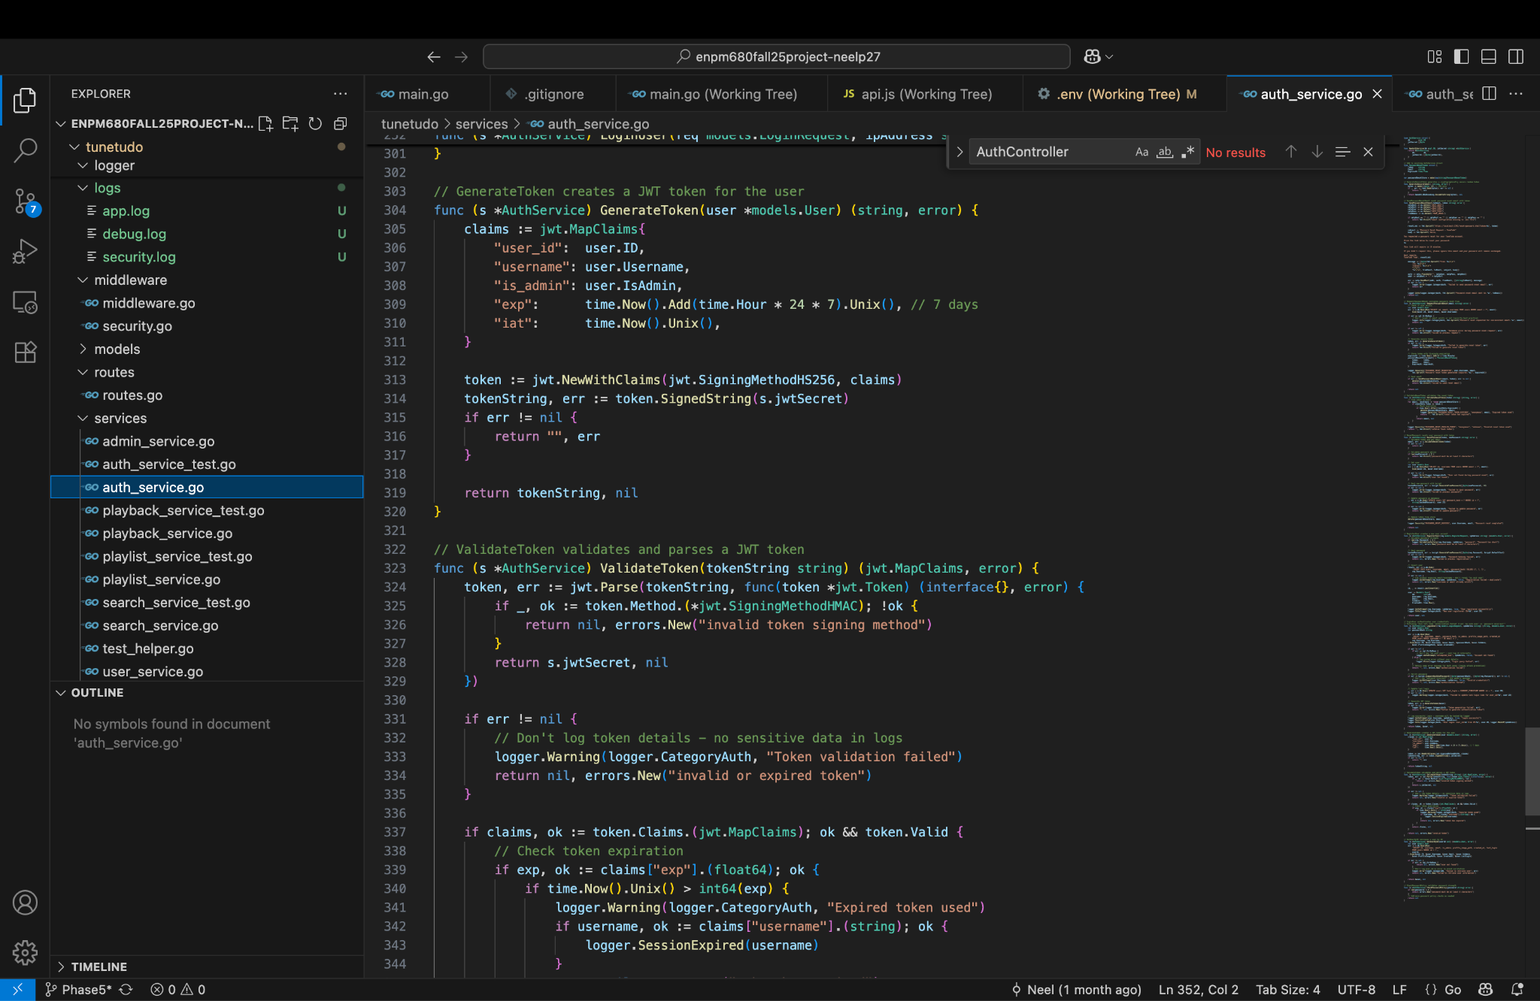

This protects from CSRF Attack as well.

#### Logging and Error Handling

[SECURITY] 2025/11/30 13:46:12 logger.go:162: Event: DATA_ACCESS | UserHash: anonymous | IP: 127.0.x.x | Details: Resource: GET /api/playlists/* | Time: 2025-11-30T13:46:12-05:00

[SECURITY] 2025/11/30 13:46:27 logger.go:162: Event: DATA_ACCESS | UserHash: anonymous | IP: 127.0.x.x | Details: Resource: GET /api/uploads | Time: 2025-11-30T13:46:27-05:00

[SECURITY] 2025/11/30 13:46:31 logger.go:162: Event: DATA_ACCESS | UserHash: anonymous | IP: 127.0.x.x | Details: Resource: GET /api/profile | Time: 2025-11-30T13:46:31-05:00

[SECURITY] 2025/11/30 13:46:31 logger.go:162: Event: DATA_ACCESS | UserHash: anonymous | IP: 127.0.x.x | Details: Resource: GET /api/playlists | Time: 2025-11-30T13:46:31-05:00

[SECURITY] 2025/11/30 13:46:31 logger.go:162: Event: DATA_ACCESS | UserHash: anonymous | IP: 127.0.x.x | Details: Resource: GET /api/uploads | Time: 2025-11-30T13:46:31-05:00

[SECURITY] 2025/11/30 16:45:02 logger.go:162: Event: VALIDATION_FAILURE | UserHash: anonymous | IP: 127.0.x.x | Details: Field: test' OR 1=1; | Reason: Suspicious pattern detected | Time: 2025-11-30T16:45:02-05:00

[SECURITY] 2025/11/30 16:45:09 logger.go:162: Event: VALIDATION_FAILURE | UserHash: anonymous | IP: 127.0.x.x | Details: Field: test' OR 1=1; | Reason: Suspicious pattern detected | Time: 2025-11-30T16:45:09-05:00

[SECURITY] 2025/11/30 16:48:19 logger.go:162: Event: DATA_ACCESS | UserHash: anonymous | IP: 127.0.x.x | Details: Resource: POST /api/auth/* | Time: 2025-11-30T16:48:19-05:00

[SECURITY] 2025/11/30 16:48:19 logger.go:162: Event: AUTH_SUCCESS | UserHash: user_63435ea6 | IP: 127.0.x.x | Details: Login successful | Time: 2025-11-30T16:48:19-05:00

[SECURITY] 2025/11/30 16:48:19 logger.go:162: Event: SESSION_CREATED | UserHash: user_63435ea6 | IP: 127.0.x.x | Details: New session established | Time: 2025-11-30T16:48:19-05:00

[SECURITY] 2025/11/30 16:48:22 logger.go:162: Event: DATA_ACCESS | UserHash: anonymous | IP: 127.0.x.x | Details: Resource: POST /api/auth/* | Time: 2025-11-30T16:48:22-05:00

[SECURITY] 2025/11/30 16:48:22 logger.go:162: Event: AUTH_SUCCESS | UserHash: user_63435ea6 | IP: 127.0.x.x | Details: Login successful | Time: 2025-11-30T16:48:22-05:00

[SECURITY] 2025/11/30 16:48:22 logger.go:162: Event: SESSION_CREATED | UserHash: user_63435ea6 | IP: 127.0.x.x | Details: New session established | Time: 2025-11-30T16:48:22-05:00

[SECURITY] 2025/11/30 16:48:27 logger.go:162: Event: DATA_ACCESS | UserHash: anonymous | IP: 127.0.x.x | Details: Resource: GET /api/playlists | Time: 2025-11-30T16:48:27-05:00

[SECURITY] 2025/11/30 16:48:30 logger.go:162: Event: DATA_ACCESS | UserHash: anonymous | IP: 127.0.x.x | Details: Resource: GET /api/uploads | Time: 2025-11-30T16:48:30-05:00

[SECURITY] 2025/11/30 16:54:26 logger.go:162: Event: VALIDATION_FAILURE | UserHash: anonymous | IP: 127.0.x.x | Details: Field: <script>alert('XSS');</script> | Reason: Suspicious pattern detected | Time: 2025-11-30T16:54:26-05:00

[SECURITY] 2025/11/30 16:58:45 logger.go:162: Event: DATA_ACCESS | UserHash: anonymous | IP: 127.0.x.x | Details: Resource: POST /api/auth/* | Time: 2025-11-30T16:58:45-05:00

[SECURITY] 2025/11/30 16:58:45 logger.go:162: Event: PASSWORD_RESET_REQUESTED | UserHash: neelnew | IP: neelpatel272000@gmail.com | Details: Password reset token generated (expires: 2025-11-30 17:13:45.548231 -0500 EST m=+2555.656547710) | Time: 2025-11-30T16:58:45-05:00

[SECURITY] 2025/11/30 16:59:06 logger.go:162: Event: DATA_ACCESS | UserHash: anonymous | IP: 127.0.x.x | Details: Resource: GET /api/auth/* | Time: 2025-11-30T16:59:06-05:00

[SECURITY] 2025/11/30 17:04:00 logger.go:162: Event: DATA_ACCESS | UserHash: anonymous | IP: 127.0.x.x | Details: Resource: POST /api/auth/* | Time: 2025-11-30T17:04:00-05:00

[SECURITY] 2025/11/30 17:04:00 logger.go:162: Event: AUTH_SUCCESS | UserHash: user_63435ea6 | IP: 127.0.x.x | Details: Login successful | Time: 2025-11-30T17:04:00-05:00

[SECURITY] 2025/11/30 17:04:00 logger.go:162: Event: SESSION_CREATED | UserHash: user_63435ea6 | IP: 127.0.x.x | Details: New session established | Time: 2025-11-30T17:04:00-05:00



Security logging is implemented as shown in above logs

[INFO] 2025/11/30 16:31:09 logger.go:120: [API] Logger initialized successfully

[INFO] 2025/11/30 16:31:09 logger.go:120: [DATABASE] Database initialized successfully

[INFO] 2025/11/30 16:31:09 logger.go:120: [DATABASE] Database migrations completed

[INFO] 2025/11/30 16:31:09 logger.go:120: [API] 🎵 TuneTudo Server starting

[INFO] 2025/11/30 16:31:14 logger.go:120: [API] Retrieved 12 recent songs

[INFO] 2025/11/30 16:31:17 logger.go:120: [API] Retrieved 12 recent songs

[INFO] 2025/11/30 16:31:19 logger.go:120: [API] Retrieved 12 recent songs

[INFO] 2025/11/30 16:31:23 logger.go:120: [API] Retrieved 12 recent songs

**[ERROR]** 2025/11/30 16:33:23 logger.go:142: [API] Request error occurred: error occurred

**[ERROR]** 2025/11/30 16:33:23 logger.go:142: [API] Request error

[INFO] 2025/11/30 16:36:55 logger.go:120: [API] Retrieved 12 recent songs

[INFO] 2025/11/30 16:37:01 logger.go:120: [API] Retrieved 12 recent songs

[INFO] 2025/11/30 16:37:02 logger.go:120: [API] Retrieved 12 recent songs

[INFO] 2025/11/30 16:48:00 logger.go:120: [API] Retrieved 12 recent songs

[INFO] 2025/11/30 16:48:00 logger.go:120: [API] Retrieved 12 recent songs

[INFO] 2025/11/30 16:48:00 logger.go:120: [API] Retrieved 12 recent songs

[INFO] 2025/11/30 16:48:00 logger.go:120: [API] Retrieved 12 recent songs

[INFO] 2025/11/30 16:48:19 logger.go:120: [AUTH] User login: user_id=3 from IP=127.0.x.x

[INFO] 2025/11/30 16:48:22 logger.go:120: [AUTH] User login: user_id=3 from IP=127.0.x.x

[INFO] 2025/11/30 16:48:23 logger.go:120: [API] Retrieved 12 recent songs

[INFO] 2025/11/30 16:53:27 logger.go:120: [API] Retrieved 12 recent songs

[INFO] 2025/11/30 16:57:49 logger.go:120: [API] Retrieved 12 recent songs

[INFO] 2025/11/30 16:58:46 logger.go:120: [AUTH] Password reset email sent to: neelpatel272000@gmail.com

[INFO] 2025/11/30 17:03:48 logger.go:120: [API] Retrieved 12 recent songs

[INFO] 2025/11/30 17:04:00 logger.go:120: [AUTH] User login: user_id=3 from IP=127.0.x.x

[INFO] 2025/11/30 17:04:01 logger.go:120: [API] Retrieved 12 recent songs

**[ERROR]** 2025/11/30 17:04:07 logger.go:142: [API] Request error occurred: error occurred

**[ERROR]** 2025/11/30 17:04:07 logger.go:142: [API] Request error

**[ERROR]** 2025/11/30 17:04:07 logger.go:142: [API] Request error occurred: error occurred

**[ERROR]** 2025/11/30 17:04:07 logger.go:142: [API] Request error

The application logs are also stored

Further, it is made sure that no sensitive data is stored in the log and the information from users are properly sanitized and validated before logging it. This prevents CRLF attacks.

Error handling is done such that no stack trace is left behind in error scenario

// Security Middleware - Applied globally

app.Use(recover.New(recover.Config{

EnableStackTrace: false, // Don't expose stack traces

}))

This ensures that no sensitive data is leaked.